Parcel 96
3675 Five Mile Rd, Town of Allegany
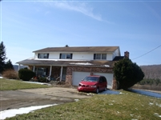 |  |  |  |  | Status: |  | Active
 |  |  |  |  | Roll Section: |  | Taxable
 |  |  |  |  | Swis: |  | 042089
 |  |  |  |  | Tax Map ID #: |  | 75.004-1-54
 |  |  |  |  | Property Class: |  | 210 - 1 Family Res
 |  |  |  |  | Site: |  | RES 1
 |  |  |  |  | In Ag. District: |  | No
 |  |  |  |  | Site Property Class: |  | 210 - 1 Family Res
 |  |  |  |  | Zoning Code: |  | AF - Af-Forest Dist.
 |  |  |  |  | Neighborhood Code: |  | 20314
Total Acreage/Size: |  |  | 147.3 x 167 |  | School District: |  | Allegany - Limestone
Land Assessment: |  |  | 2017 - $9,800 |  | Total Assessment: |  | 2017 - $50,000
Full Market Value: |  |  | 2017 - $51,546
Living Area: |  |  | 2,822 sq. ft. |  | First Story Area: |  |  |  | 1,322 sq. ft.
Second Story Area: |  |  | 1,500 sq. ft. |  | Half Story Area: |  |  |  | 0 sq. ft.
Finished Basement: |  |  | 0 sq. ft. |  | Number of Stories: |  |  |  | 2
Building Style: |  |  | Colonial |  | Bathrooms (Full - Half): |  |  |  | 1 - 1
Bedrooms: |  |  | 5 |  | Kitchens: |  |  |  | 1
Fireplaces: |  |  | 1 |  | Basement Type: |  |  |  | Full
Porch Type: |  |  | Porch-covered |  | Porch Area: |  |  |  | 306.00
Basement Garage Cap: |  |  | 0 |  | Attached Garage Cap: |  |  |  | 576.00 sq. ft.
Overall Condition: |  |  | Fair |  | Overall Grade: |  |  |  | Average
Year Built: |  |  | 1973
Structure | Size |  |  | Grade |  | Condition |  | Year
Porch-covered |  | 306.00 sq. ft. |  | Average |  | Normal |  | 1973
Gar-1.0 attached |  | 576.00 sq. ft.  MINIMUM BID $25,000 |  | Average |  | Normal |  | 1973
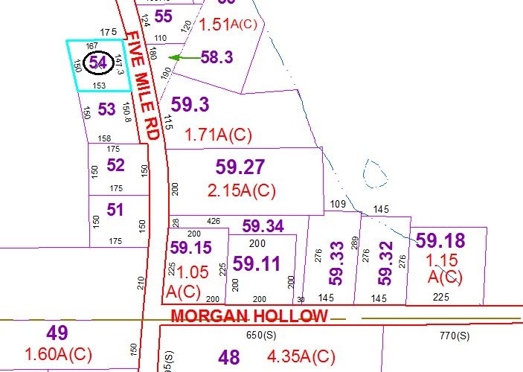
Approximate Yearly Taxes

School $881
Town/County $960

Total $1,841

