Parcel 9
110 Twelfth St N, City of Olean
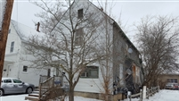 |  |  |  |  |  | Status: |  |  | Active
 |  |  |  |  |  | Roll Section: |  |  | Taxable
 |  |  |  |  |  | Swis: |  |  | 041200
 |  |  |  |  |  | Tax Map ID #: |  |  | 94.064-6-74
 |  |  |  |  |  | Property Class: |  |  | 210 - 1 Family Res
 |  |  |  |  |  | Site: |  |  | RES 1
 |  |  |  |  |  | In Ag. District: |  |  | No
 |  |  |  |  |  | Site Property Class: |  |  | 210 - 1 Family Res
 |  |  |  |  |  | Zoning Code: |  |  | -
 |  |  |  |  |  | Neighborhood Code: |  |  | 12204
Total Acreage/Size: |  |  | 30 x 101.7 |  |  | School District: |  |  | Olean
Land Assessment: |  |  | 2017 - $2,400 |  |  | Total Assessment: |  |  | 2017 - $17,000
Full Market Value: |  |  | 2017 - $19,101
Living Area: |  | 1,774 sq. ft. |  |  | First Story Area: |  |  |  | 1,071 sq. ft.
Second Story Area: |  | 703 sq. ft. |  |  | Half Story Area: |  |  |  | 0 sq. ft.
Finished Basement: |  | 0 sq. ft. |  |  | Number of Stories: |  |  |  | 2
Building Style: |  | Old style |  |  | Bathrooms (Full - Half): |  |  |  | 2 - 0
Bedrooms: |  | 3 |  |  | Kitchens: |  |  |  | 1
Fireplaces: |  | 0 |  |  | Basement Type: |  |  |  | Partial
Overall Condition: |  | Poor |  |  | Overall Grade: |  |  |  | Economy
Year Built: |  | 1940
Structure | Size |  |  | Grade |  |  | Condition |  |  | Year
Shed-aluminum | 8 × 10 |  |  | Average |  |  | Poor |  |  | 1970
User defined | MINIMUM BID $2500  [Type a quote from the document or the summary of an interesting point. You can position the text box anywhere in the document. Use the Drawing Tools tab to change the formatting of the pull quote text box.] |  |  | Average |  |  | Fair |  |  | 1970
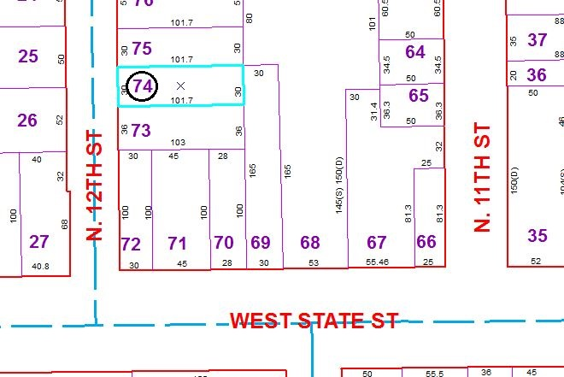
Approximate Yearly Taxes

School $444
City $248
County $238

Total $930

