Parcel 79A
491 Prospect Ave, City of Olean
No Photo Available |  | Status: | Active
 |  | Roll Section: | Taxable
 |  | Swis: | 041200
 |  | Tax Map ID #: | 94.050-3-27
 |  | Property Class: | 311 - Res vac land
 |  | Site: | RES 1
 |  | In Ag. District: | No
 |  | Site Property Class: | 311 - Res vac land
 |  | Zoning Code: | -
 |  | Neighborhood Code: | 12208
Total Acreage/Size: | 1.18 | School District: | Olean
Land Assessment: | 2017 - $25,000 | Total Assessment: | 2017 - $25,000
Full Market Value: | 2017 - $28,090
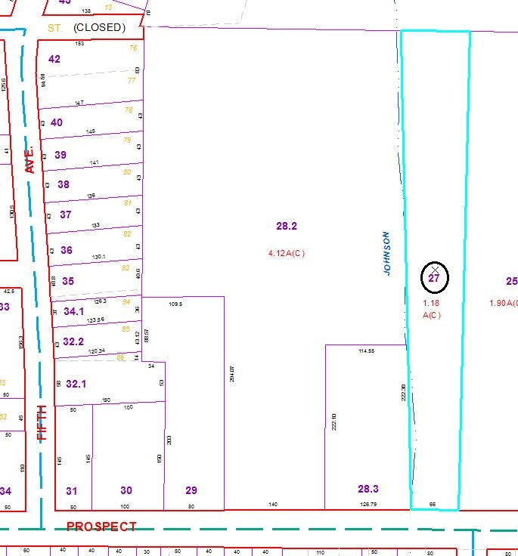
Approximate Yearly Taxes

School $653
City $364
County $350

Total $1,367

