Parcel 79
123 Stowell Ave, City of Olean
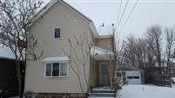 |  |  |  |  | Status: |  | Active
 |  |  |  |  | Roll Section: |  | Taxable
 |  |  |  |  | Swis: |  | 041200
 |  |  |  |  | Tax Map ID #: |  | 94.067-8-20
 |  |  |  |  | Property Class: |  | 210 - 1 Family Res
 |  |  |  |  | Site: |  | RES 1
 |  |  |  |  | In Ag. District: |  | No
 |  |  |  |  | Site Property Class: |  | 210 - 1 Family Res
 |  |  |  |  | Zoning Code: |  | -
 |  |  |  |  | Neighborhood Code: |  | 12205
Total Acreage/Size: |  |  | 52 x 92.7 |  | School District: |  | Olean
Land Assessment: |  |  | 2017 - $4,200 |  | Total Assessment: |  | 2017 - $53,000
Full Market Value: |  |  | 2017 - $59,551
Living Area: |  |  | 1,648 sq. ft. |  | First Story Area: |  |  |  | 824 sq. ft.
Second Story Area: |  |  | 824 sq. ft. |  | Half Story Area: |  |  |  | 0 sq. ft.
Finished Basement: |  |  | 0 sq. ft. |  | Number of Stories: |  |  |  | 2
Building Style: |  |  | Old style |  | Bathrooms (Full - Half): |  |  |  | 1 - 0
Bedrooms: |  |  | 4 |  | Kitchens: |  |  |  | 1
Fireplaces: |  |  | 0 |  | Basement Type: |  |  |  | Full
Porch Type: |  |  | Porch-covered |  | Porch Area: |  |  |  | 60.00
Overall Condition: |  |  | Normal |  | Overall Grade: |  |  |  | Average
Year Built: |  |  | 1915
Structure | Size |  |  | Grade |  | Condition |  | Year
Porch-covered |  | 5 × 12 |  | Average |  | Normal |  | 1915
Gar-1.0 detached |  | 20 × 24 |  | Average |  | Normal |  | 1915
Porch-covered |  | 5 × 12  MINIMUM BID $5000 |  | Average |  | Normal |  | 1915
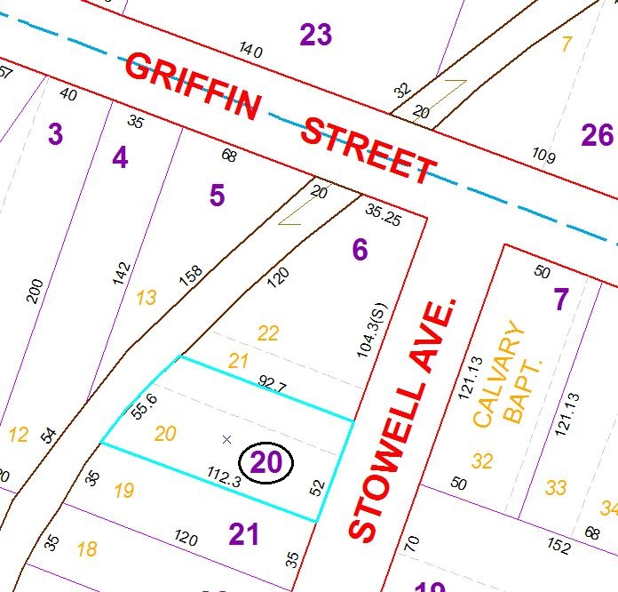
Approximate Yearly Taxes

School $1,384
City $772
County $742

Total $2,898

