Parcel 78
1123 State St W, City of Olean
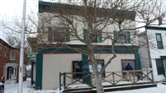 |  |  |  |  |  |  |  |  |  | Status: |  |  |  |  |  | Active
 |  |  |  |  |  |  |  |  |  | Roll Section: |  |  |  |  |  | Taxable
 |  |  |  |  |  |  |  |  |  | Swis: |  |  |  |  |  | 041200
 |  |  |  |  |  |  |  |  |  | Tax Map ID #: |  |  |  |  |  | 94.064-11-2
 |  |  |  |  |  |  |  |  |  | Property Class: |  |  |  |  |  | 421 - Restaurant
 |  |  |  |  |  |  |  |  |  | Site: |  |  |  |  |  | COM 1
 |  |  |  |  |  |  |  |  |  | In Ag. District: |  |  |  |  |  | No
 |  |  |  |  |  |  |  |  |  | Site Property Class: |  |  |  |  |  | 421 - Restaurant
 |  |  |  |  |  |  |  |  |  | Zoning Code: |  |  |  |  |  | -
 |  |  |  |  |  |  |  |  |  | Neighborhood Code: |  |  |  |  |  | 12403
Total Acreage/Size: |  |  |  |  | 50 x 135 |  |  |  |  | School District: |  |  |  |  |  | Olean
Land Assessment: |  |  |  |  | 2017 - $21,300 |  |  |  |  | Total Assessment: |  |  |  |  |  | 2017 - $95,000
Full Market Value: |  |  |  |  | 2017 - $106,742
Overall Eff Year Built: |  |  |  | 0 |  |  |  |  | Overall Condition: |  |  |  |  | Normal
Overall Grade: |  |  |  | Average |  |  |  |  | Overall Desirability: |  |  |  |  | 3
AC% | Sprinkler% | Alarm% |  |  |  | Elevators |  | Basement Type |  |  |  | Year Built | Condition |  |  |  | Quality | Gross Floor Area (sqft) |  |  |  | Stories
0 | 0 | 0 |  |  |  | 0 |  | Unfinished |  |  |  | 1900 | Normal |  |  |  | Average | 5576 |  |  |  | 2
Structure |  |  | Size |  |  |  | Grade |  |  |  | Condition |  |  |  | Year
Porch-covered |  |  | 5 × 30 |  |  |  | Average |  |  |  | Normal |  |  |  | 1900
Porch-open/deck |  |  | 6 × 22 |  |  |  | Average |  |  |  | Excellent |  |  |  | 2003
Porch-up covered |  |  | 6 × 16  MINIMUM BID $2500 |  |  |  | Average |  |  |  | Normal |  |  |  | 2006
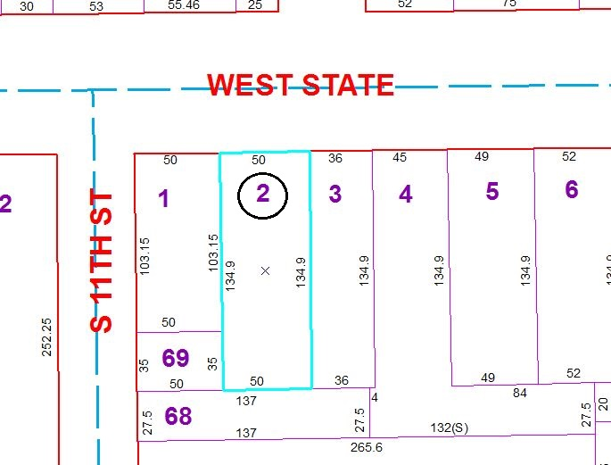
Approximate Yearly Taxes

School $2,481
City $1,384
County $1,328

Total $5,193

