Parcel 72
105 Jefferson St, City of Olean
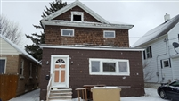 |  |  |  |  |  |  | Status: |  |  |  | Active
 |  |  |  |  |  |  | Roll Section: |  |  |  | Taxable
 |  |  |  |  |  |  | Swis: |  |  |  | 041200
 |  |  |  |  |  |  | Tax Map ID #: |  |  |  | 94.075-5-27
 |  |  |  |  |  |  | Property Class: |  |  |  | 210 - 1 Family Res
 |  |  |  |  |  |  | Site: |  |  |  | RES 1
 |  |  |  |  |  |  | In Ag. District: |  |  |  | No
 |  |  |  |  |  |  | Site Property Class: |  |  |  | 210 - 1 Family Res
 |  |  |  |  |  |  | Zoning Code: |  |  |  | -
 |  |  |  |  |  |  | Neighborhood Code: |  |  |  | 12205
Total Acreage/Size: |  |  |  | 40 x 135 |  |  | School District: |  |  |  | Olean
Land Assessment: |  |  |  | 2017 - $4,500 |  |  | Total Assessment: |  |  |  | 2017 - $16,500
Full Market Value: |  |  |  | 2017 - $18,539
Living Area: |  |  | 1,440 sq. ft. |  |  | First Story Area: |  |  |  |  |  | 720 sq. ft.
Second Story Area: |  |  | 720 sq. ft. |  |  | Half Story Area: |  |  |  |  |  | 0 sq. ft.
Finished Basement: |  |  | 0 sq. ft. |  |  | Number of Stories: |  |  |  |  |  | 2
Building Style: |  |  | Old style |  |  | Bathrooms (Full - Half): |  |  |  |  |  | 1 - 0
Bedrooms: |  |  | 4 |  |  | Kitchens: |  |  |  |  |  | 1
Fireplaces: |  |  | 0 |  |  | Basement Type: |  |  |  |  |  | Full
Porch Type: |  |  | Porch-enclosed |  |  | Porch Area: |  |  |  |  |  | 192.00
Overall Condition: |  |  | Poor |  |  | Overall Grade: |  |  |  |  |  | Economy
Year Built: |  |  | 1916
Structure | Size |  |  |  | Grade |  |  | Condition |  | Year
Porch-enclosed |  | 8 × 24 |  |  | Economy |  |  | Poor |  | 1916
Porch-enclosed |  | 6 × 12 |  |  | Economy |  |  | Poor |  | 1916
Carport |  | 20 × 22 |  |  | Economy |  |  | Poor |  | 1916
Porch-open/deck |  | 6 × 12  MINIMUM BID $2500 |  |  | Economy |  |  | Poor |  | 1916
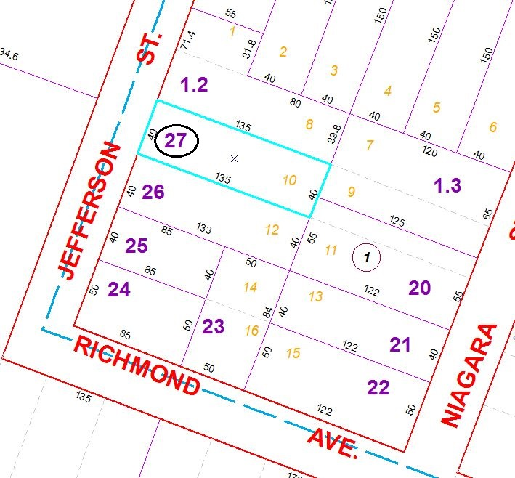
Approximate Yearly Taxes

School $431
City $241
County $230

Total $902

