Parcel 71
315 Genesee St, City of Olean
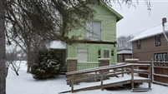 |  |  |  | Status: |  | Active
 |  |  |  | Roll Section: |  | Taxable
 |  |  |  | Swis: |  | 041200
 |  |  |  | Tax Map ID #: |  | 94.042-4-61
 |  |  |  | Property Class: |  | 210 - 1 Family Res
 |  |  |  | Site: |  | RES 1
 |  |  |  | In Ag. District: |  | No
 |  |  |  | Site Property Class: |  | 210 - 1 Family Res
 |  |  |  | Zoning Code: |  | -
 |  |  |  | Neighborhood Code: |  | 12208
Total Acreage/Size: |  | 50 x 150 |  | School District: |  | Olean
Land Assessment: |  | 2017 - $13,800 |  | Total Assessment: |  | 2017 - $35,000
Full Market Value: |  | 2017 - $39,326
Living Area: |  | 1,280 sq. ft. |  | First Story Area: |  |  | 640 sq. ft.
Second Story Area: |  | 640 sq. ft. |  | Half Story Area: |  |  | 0 sq. ft.
Finished Basement: |  | 0 sq. ft. |  | Number of Stories: |  |  | 2
Building Style: |  | Old style |  | Bathrooms (Full - Half): |  |  | 1 - 1
Bedrooms: |  | 3 |  | Kitchens: |  |  | 1
Fireplaces: |  | 0 |  | Basement Type: |  |  | Full
Porch Type: |  | Porch-covered |  | Porch Area: |  |  | 160.00
Overall Condition: |  | Fair |  | Overall Grade: |  |  | Average
Year Built: |  | 1928
Structure | Size |  | Grade |  | Condition |  | Year
Porch-covered | 10 × 16 |  | Average |  | Fair |  | 1928
Porch-up open | 10 × 16 |  | Average |  | Fair |  | 1928
Porch-covered | 5 × 10 |  | Average |  | Fair |  | 1928
Porch-covered | 4 × 5  MINIMUM BID $2500 |  | Average |  | Fair |  | 0
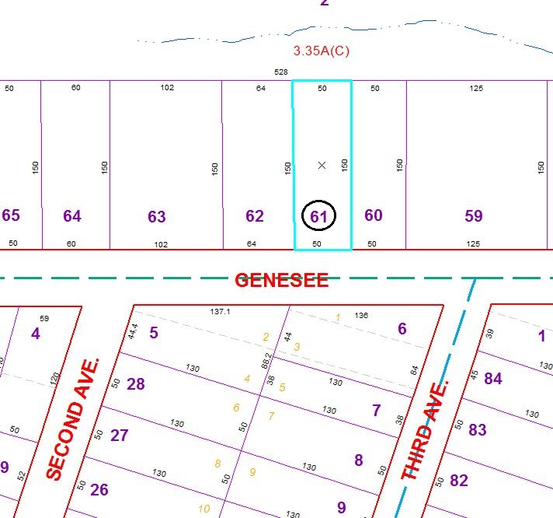
Approximate Yearly Taxes

School $914
City $510
County $490

Total $1,914

