Parcel 65
309 Second St S, City of Olean
 | 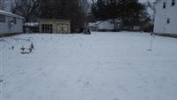 |  |  |  | Status: |  | Active
 |  |  |  |  | Roll Section: |  | Taxable
 |  |  |  |  | Swis: |  | 041200
 |  |  |  |  | Tax Map ID #: |  | 94.073-3-46.2
 |  |  |  |  | Property Class: |  | 312 - Vac w/improvement
 |  |  |  |  | Site: |  | RES 1
 |  |  |  |  | In Ag. District: |  | No
 |  |  |  |  | Site Property Class: |  | 312 - Vac w/improvement
 |  |  |  |  | Zoning Code: |  | -
 |  |  |  |  | Neighborhood Code: |  | 12203
 | Total Acreage/Size: |  | 37 x 125 |  | School District: |  | Olean
 | Land Assessment: |  | 2017 - $3,300 |  | Total Assessment: |  | 2017 - $3,300
 | Full Market Value: |  | 2017 -$3,708
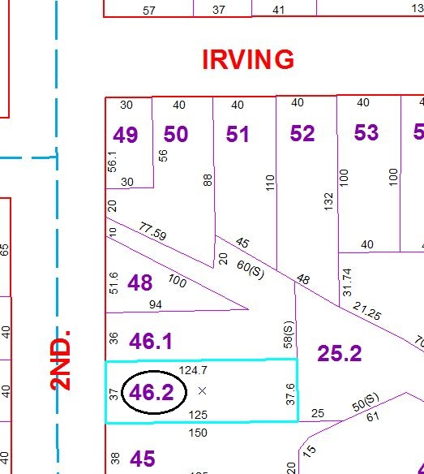
Approximate Yearly Taxes

School $86
City $48
County $47

Total $181

