Parcel 64
213 Pine St W, City of Olean
NO PHOTO AVAILABLE |  | Status: | Active
 |  | Roll Section: | Taxable
 |  | Swis: | 041200
 |  | Tax Map ID #: | 94.040-2-50
 |  | Property Class: | 311 - Res vac land
 |  | Site: | RES 1
 |  | In Ag. District: | No
 |  | Site Property Class: | 311 - Res vac land
 |  | Zoning Code: | -
 |  | Neighborhood Code: | 12205
Total Acreage/Size: | 97.5 x 132 | School District: | Olean
Land Assessment: | 2017 - $7,600 | Total Assessment: | 2017 - $7,600
Full Market Value: | 2017 -$8,539
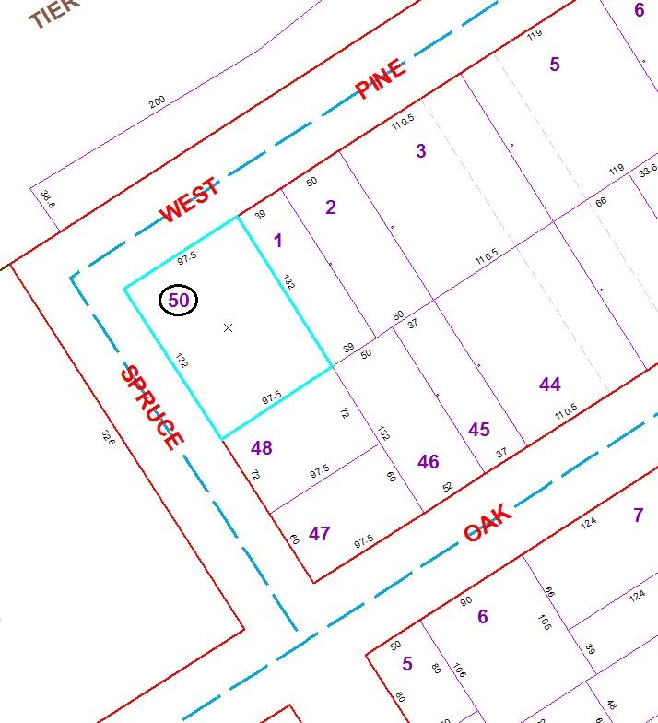
Approximate Yearly Taxes

School $198
City $111
County $107

Total $416

