Parcel 371
8677 Sawmill Run Rd, Town of Salamanca
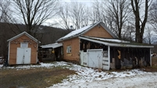 |  |  |  |  |  | Status: |  |  |  | Active
 |  |  |  |  |  | Roll Section: |  |  |  | Taxable
 |  |  |  |  |  | Swis: |  |  |  | 048000
 |  |  |  |  |  | Tax Map ID #: |  |  |  | 72.003-2-12
 |  |  |  |  |  | Property Class: |  |  |  | 210 - 1 Family Res
 |  |  |  |  |  | Site: |  |  |  | RES 1
 |  |  |  |  |  | In Ag. District: |  |  |  | No
 |  |  |  |  |  | Site Property Class: |  |  |  | 210 - 1 Family Res
 |  |  |  |  |  | Zoning Code: |  |  |  | CON
 |  |  |  |  |  | Neighborhood Code: |  |  |  | 80350
Total Acreage/Size: |  |  | 231 x 100 |  |  | School District: |  |  |  | Salamanca
Land Assessment: |  |  | 2017 - $6,600 |  |  | Total Assessment: |  |  |  | 2017 - $43,800
Full Market Value: |  |  | 2017 - $50,345
Living Area: |  | 828 sq. ft. |  |  | First Story Area: |  |  |  |  | 828 sq. ft.
Finished Basement: |  | 0 sq. ft.
Building Style: |  | Cottage |  |  | Bathrooms (Full - Half): |  |  |  |  | 1 - 0
Bedrooms: |  | 2 |  |  | Kitchens: |  |  |  |  | 1
Fireplaces: |  | 0 |  |  | Basement Type: |  |  |  |  | Slab/pier
Porch Type: |  | Porch-covered |  |  | Porch Area: |  |  |  |  | 90.00
Basement Garage Cap: |  | 0 |  |  | Attached Garage Cap: |  |  |  |  | 396.00 sq. ft.
Overall Condition: |  | Normal |  |  | Overall Grade: |  |  |  |  | Economy
Year Built: |  | 1940
Structure | Size |  |  | Grade |  |  | Condition | Year
Gar-1.0 attached | 18 × 22 |  |  | Economy |  |  | Normal | 2001
Shed-machine | 12 × 16 |  |  | Economy |  |  | Fair | 1960
Porch-covered | 15 × 6 |  |  | Average |  |  | Normal | 1990
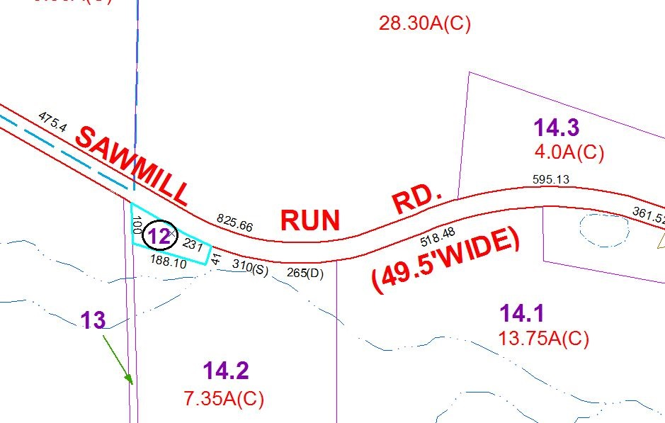
Approximate Yearly Taxes

School $279
Town/County $908

Total $1,187

