Parcel 355A
421 Portville Eldred Rd, Town of Portville
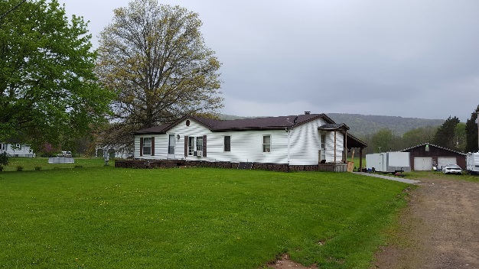 |  |  |  | Status: |  |  | Active
 |  |  |  | Roll Section: |  |  | Taxable
 |  |  |  | Swis: |  |  | 047489
 |  |  |  | Tax Map ID #: |  |  | 113.002-1-2
 |  |  |  | Property Class: |  |  | 210 - 1 Family Res
 |  |  |  | Site: |  |  | RES 1
 |  |  |  | In Ag. District: |  |  | No
 |  |  |  | Site Property Class: |  |  | 210 - 1 Family Res
 |  |  |  | Zoning Code: |  |  | CON - CONFORMING
 |  |  |  | Neighborhood Code: |  |  | 74050
Total Acreage/Size: |  | 2.00 |  | School District: |  |  | Portville
Land Assessment: |  | 2017 - $11,200 |  | Total Assessment: |  |  | 2017 - $71,200
Full Market Value: |  | 2017 - $74,947
Living Area: |  | 1,352 sq. ft. |  | First Story Area: |  |  |  | 1,352 sq. ft.
Finished Basement: |  | 0 sq. ft. |  | Number of Stories: |  |  |  | 1
Building Style: |  | Ranch |  | Bathrooms (Full - Half): |  |  |  | 2 - 0
Bedrooms: |  | 3 |  | Kitchens: |  |  |  | 1
Fireplaces: |  | 0 |  | Basement Type: |  |  |  | Crawl
Porch Type: |  | Porch-open/deck |  | Porch Area: |  |  |  | 312.00
Overall Condition: |  | Normal |  | Overall Grade: |  |  |  | Economy
Year Built: |  | 1992
Structure | Size |  | Grade |  | Condition | Year
Gar-1.0 detached | 30 × 38 |  | Average |  | Normal | 1980
Porch-open/deck | 12 × 26 |  | Average |  | Normal | 1992
Porch-open/deck | 12 × 12 |  | Average |  | Normal | 1992
Porch-covered | 14 × 52 |  | Average |  | Normal  Approximate Yearly Taxes  School $1,642  Town/County $1,214  Total $2,856 | 1992
