Parcel 353
1350 Portville Olean Rd, Town of Portville
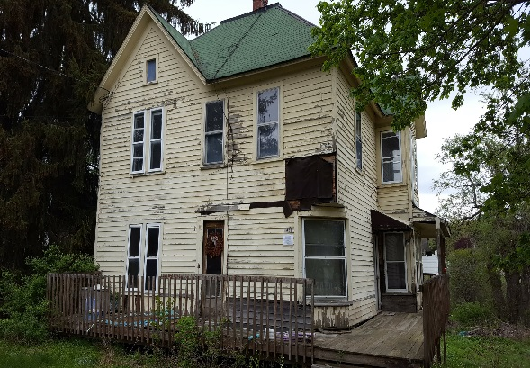 |  |  |  | Status: |  |  | Active
 |  |  |  | Roll Section: |  |  | Taxable
 |  |  |  | Swis: |  |  | 047489
 |  |  |  | Tax Map ID #: |  |  | 104.005-1-7
 |  |  |  | Property Class: |  |  | 210 - 1 Family Res
 |  |  |  | Site: |  |  | RES 1
 |  |  |  | In Ag. District: |  |  | No
 |  |  |  | Site Property Class: |  |  | 210 - 1 Family Res
 |  |  |  | Zoning Code: |  |  | CON - CONFORMING
 |  |  |  | Neighborhood Code: |  |  | 74050
Total Acreage/Size: |  | 62 x 231 |  | School District: |  |  | Portville
Land Assessment: |  | 2017 - $7,500 |  | Total Assessment: |  |  | 2017 - $27,000
Full Market Value: |  | 2017 - $28,421
Living Area: |  | 1,802 sq. ft. |  | First Story Area: |  |  |  | 1,064 sq. ft.
Second Story Area: |  | 738 sq. ft. |  | Half Story Area: |  |  |  | 0 sq. ft.
Finished Basement: |  | 0 sq. ft. |  | Number of Stories: |  |  |  | 2
Building Style: |  | Old style |  | Bathrooms (Full - Half): |  |  |  | 2 - 0
Bedrooms: |  | 3 |  | Kitchens: |  |  |  | 1
Fireplaces: |  | 0 |  | Basement Type: |  |  |  | Partial
Porch Type: |  | Porch-covered |  | Porch Area: |  |  |  | 321.00
Overall Condition: |  | Poor |  | Overall Grade: |  |  |  | Average
Year Built: |  | 1920
Structure | Size |  | Grade |  | Condition | Year
Porch-covered | 321.00 sq. ft.  Approximate Yearly Taxes  School $623  Town/County $465  Total $1,088 |  | Average |  | Poor | 1920
