Parcel 34
257-R Riverside Dr. E, City of Olean
No Photo Available |  | Status: | Active
 |  | Roll Section: | Taxable
 |  | Swis: | 041200
 |  | Tax Map ID #: | 94.074-1-21
 |  | Property Class: | 311 - Res vac land
 |  | Site: | RES 1
 |  | In Ag. District: | No
 |  | Site Property Class: | 311 - Res vac land
 |  | Zoning Code: | -
 |  | Neighborhood Code: | 12209
Total Acreage/Size: | 25.37 | School District: | Olean
Land Assessment: | 2017 - $3,500 | Total Assessment: | 2017 - $3,500
Full Market Value: | 2017 - $3,933
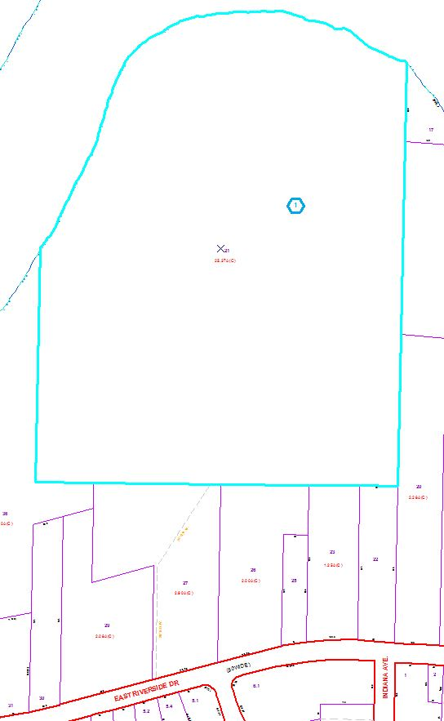
Approximate Yearly Taxes

School $92
City $51
County $49

Total $192

