Parcel 332A
R12429 Mackinaw Rd, Town of Perrysburg
No Photo Available |  | Status: | Active
 |  | Roll Section: | Taxable
 |  | Swis: | 047000
 |  | Tax Map ID #: | 7.002-1-23.3
 |  | Property Class: | 322 - Rural vac>10
 |  | Site: | RES 1
 |  | In Ag. District: | No
 |  | Site Property Class: | 322 - Rural vac>10
 |  | Zoning Code: | -
 |  | Neighborhood Code: | 70150
Total Acreage/Size: | 22.35 | School District: | Gowanda
Land Assessment: | 2017 - $8,900 | Total Assessment: | 2017 - $8,900
Full Market Value:  LANDLOCKED | 2017 - $13,485
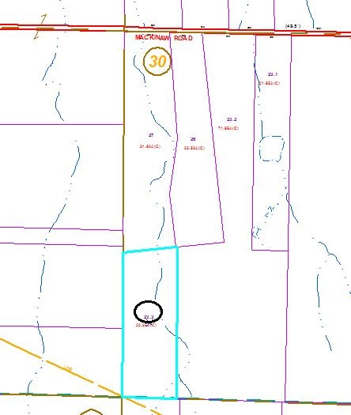
Approximate Yearly Taxes

School $228
Town/County $241

Total $469

