Parcel 330
12353 Planck Rd, Town of Perrysburg
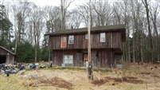 |  |  |  |  | Status: |  |  |  | Active
 |  |  |  |  | Roll Section: |  |  |  | Taxable
 |  |  |  |  | Swis: |  |  |  | 047000
 |  |  |  |  | Tax Map ID #: |  |  |  | 7.002-1-13
 |  |  |  |  | Property Class: |  |  |  | 210 - 1 Family Res
 |  |  |  |  | Site: |  |  |  | RES 1
 |  |  |  |  | In Ag. District: |  |  |  | No
 |  |  |  |  | Site Property Class: |  |  |  | 210 - 1 Family Res
 |  |  |  |  | Zoning Code: |  |  |  | -
 |  |  |  |  | Neighborhood Code: |  |  |  | 70350
Total Acreage/Size: |  |  | 5.89 |  | School District: |  |  |  | Gowanda
Land Assessment: |  |  | 2017 - $11,800 |  | Total Assessment: |  |  |  | 2017 - $83,800
Full Market Value: |  |  | 2017 - $126,970
Living Area: |  | 1,946 sq. ft. |  |  | First Story Area: |  |  |  |  | 762 sq. ft.
Second Story Area: |  | 1,184 sq. ft. |  |  | Half Story Area: |  |  |  |  | 0 sq. ft.
Finished Basement: |  | 0 sq. ft. |  |  | Number of Stories: |  |  |  |  | 2
Building Style: |  | Contemporary |  |  | Bathrooms (Full - Half): |  |  |  |  | 1 - 1
Bedrooms: |  | 3 |  |  | Kitchens: |  |  |  |  | 1
Fireplaces: |  | 0 |  |  | Basement Type: |  |  |  |  | Slab/pier
Porch Type: |  | Porch-enclosed |  |  | Porch Area: |  |  |  |  | 96.00
Overall Condition: |  | Normal |  |  | Overall Grade: |  |  |  |  | Average
Year Built: |  | 1997
Structure | Size |  |  | Grade |  | Condition | Year
Shed-machine | 6 × 12 |  |  | Economy |  | Fair | 1997
Gar-1.0 detached | 24 × 32 |  |  | Average |  | Normal | 1999
Porch-enclosed | 4 × 24 |  |  | Average |  | Normal | 1997
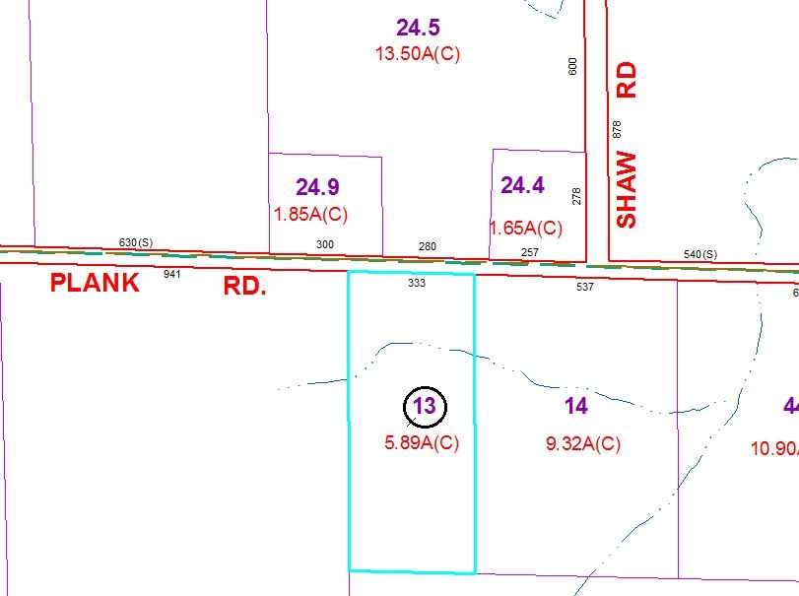
Approximate Yearly Taxes

School $2,145
Town/County $2,264

Total $4,409

