Parcel 320
Indiana Ave, Town of Olean
No Photo Available |  | Status: | Active
 |  | Roll Section: | Taxable
 |  | Swis: | 046600
 |  | Tax Map ID #: | 103.002-1-15
 |  | Property Class: | 314 - Rural vac<10
 |  | Site: | RES 1
 |  | In Ag. District: | No
 |  | Site Property Class: | 314 - Rural vac<10
 |  | Zoning Code: | -
 |  | Neighborhood Code: | 66350
Total Acreage/Size: | 100 x 100 | School District: | Olean
Land Assessment: | 2017 - $2,400 | Total Assessment: | 2017 - $2,400
Full Market Value: | 2017 - $3,117
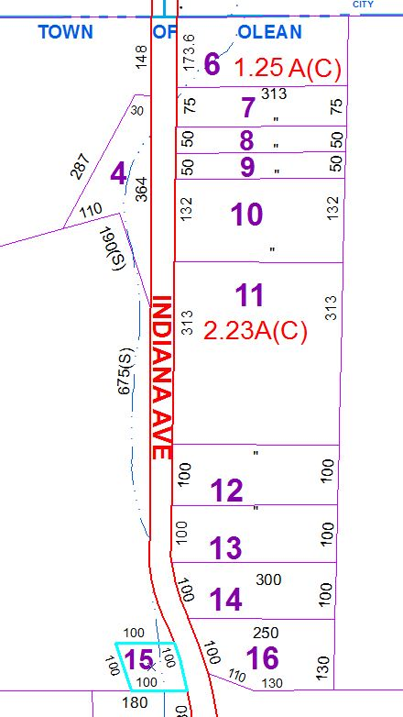
Approximate Yearly Taxes

School $74
Town/County $55

Total $129

