Parcel 315
Indiana Ave, Town of Olean
No Photo Available |  | Status: | Active
 |  | Roll Section: | Taxable
 |  | Swis: | 046600
 |  | Tax Map ID #: | 103.002-1-12
 |  | Property Class: | 314 - Rural vac<10
 |  | Site: | RES 1
 |  | In Ag. District: | No
 |  | Site Property Class: | 314 - Rural vac<10
 |  | Zoning Code: | -
 |  | Neighborhood Code: | 66350
Total Acreage/Size: | 100 x 313 | School District: | Olean
Land Assessment: | 2017 - $3,300 | Total Assessment: | 2017 - $3,300
Full Market Value: | 2017 - $4,286
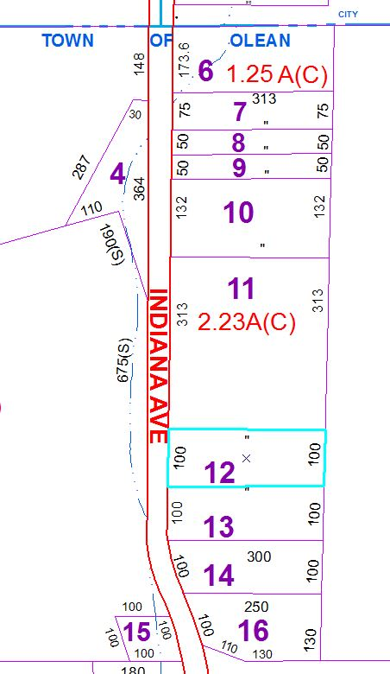
Approximate Yearly Taxes

School $102
Town/County $75

Total $177

