Parcel 313
Jackson Ave, Town of Olean
No Photo Available |  | Status: | Active
 |  | Roll Section: | Taxable
 |  | Swis: | 046600
 |  | Tax Map ID #: | 94.076-1-45
 |  | Property Class: | 314 - Rural vac<10
 |  | Site: | RES 1
 |  | In Ag. District: | No
 |  | Site Property Class: | 314 - Rural vac<10
 |  | Zoning Code: | -
 |  | Neighborhood Code: | 66370
Total Acreage/Size: | 3.82 | School District: | Olean
Land Assessment: | 2017 - $14,200 | Total Assessment: | 2017 - $14,200
Full Market Value: | 2017 - $18,442
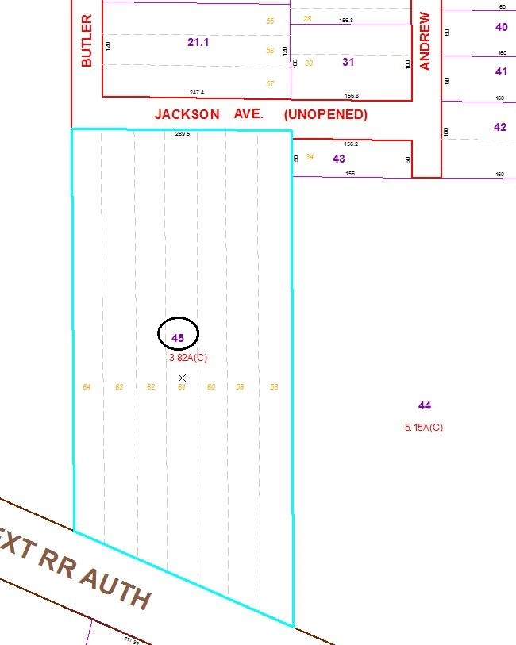
Approximate Yearly Taxes

School $438
Town/County $330

Total $768

