Parcel 312
2650 Wildcat Rd, Town of Olean
 |  |  |  | Status: |  |  | Active
 |  |  |  | Roll Section: |  |  | Taxable
 |  |  |  | Swis: |  |  | 046600
 |  |  |  | Tax Map ID #: |  |  | 103.001-3-55.2
 |  |  |  | Property Class: |  |  | 210 - 1 Family Res
 |  |  |  | Site: |  |  | RES 1
 |  |  |  | In Ag. District: |  |  | No
 |  |  |  | Site Property Class: |  |  | 210 - 1 Family Res
 |  |  |  | Zoning Code: |  |  | -
 |  |  |  | Neighborhood Code: |  |  | 66350
Total Acreage/Size: |  | 1.25 |  | School District: |  |  | Olean
Land Assessment: |  | 2017 - $4,200 |  | Total Assessment: |  |  | 2017 - $15,500
Full Market Value: |  | 2017 - $20,130
Living Area: |  | 792 sq. ft. |  | First Story Area: |  |  |  | 792 sq. ft.
Finished Basement: |  | 0 sq. ft. |  | Number of Stories: |  |  |  | 1
Building Style: |  | Cottage |  | Bathrooms (Full - Half): |  |  |  | 1 - 0
Bedrooms: |  | 2 |  | Kitchens: |  |  |  | 1
Fireplaces: |  | 0 |  | Basement Type: |  |  |  | Slab/pier
Porch Type: |  | Porch-open/deck |  | Porch Area: |  |  |  | 84.00
Overall Condition: |  | Fair |  | Overall Grade: |  |  |  | Economy
Year Built: |  | 1920
Structure | Size |  | Grade |  | Condition | Year
Porch-open/deck | 7 × 12 |  | Minimum |  | Fair | 1920
Porch-covered | 119.00 sq. ft. |  | Average |  | Normal | 1920
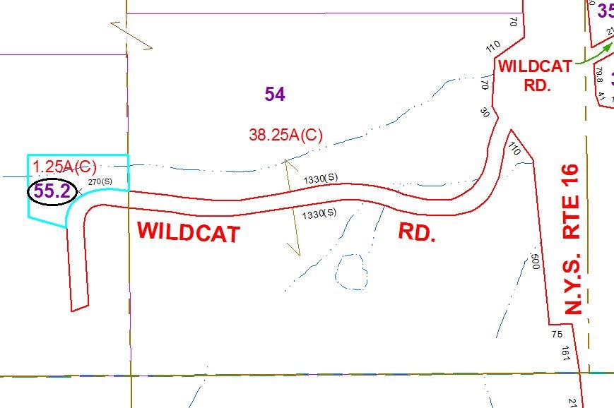
Approximate Yearly Taxes

School $478
Town/County $350

Total $828

