Parcel 310A
180 Jefferson St, Village of Cattaraugus
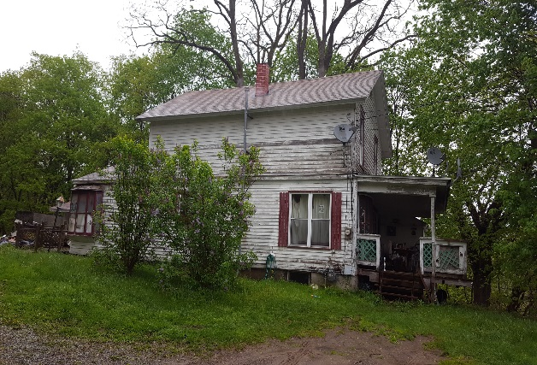 |  |  |  | Status: |  |  | Active
 |  |  |  | Roll Section: |  |  | Taxable
 |  |  |  | Swis: |  |  | 046401
 |  |  |  | Tax Map ID #: |  |  | 35.074-2-8
 |  |  |  | Property Class: |  |  | 210 - 1 Family Res
 |  |  |  | Site: |  |  | RES 1
 |  |  |  | In Ag. District: |  |  | No
 |  |  |  | Site Property Class: |  |  | 210 - 1 Family Res
 |  |  |  | Zoning Code: |  |  | -
 |  |  |  | Neighborhood Code: |  |  | 00000
Total Acreage/Size: |  | 197 x 210 |  | School District: |  |  | Cattaraugus - Little Valley
Land Assessment: |  | 2017 - $5,500 |  | Total Assessment: |  |  | 2017 - $30,000
Full Market Value: |  | 2017 - $45,455
Living Area: |  | 2,640 sq. ft. |  | First Story Area: |  |  |  | 1,560 sq. ft.
Second Story Area: |  | 1,080 sq. ft. |  | Half Story Area: |  |  |  | 0 sq. ft.
Finished Basement: |  | 0 sq. ft. |  | Number of Stories: |  |  |  | 2
Building Style: |  | Old style |  | Bathrooms (Full - Half): |  |  |  | 1 - 0
Bedrooms: |  | 3 |  | Kitchens: |  |  |  | 1
Fireplaces: |  | 0 |  | Basement Type: |  |  |  | Partial
Porch Type: |  | Porch-enclosed |  | Porch Area: |  |  |  | 280.00
Basement Garage Cap: |  | 0 |  | Attached Garage Cap: |  |  |  | 528.00 sq. ft.
Overall Condition: |  | Fair |  | Overall Grade: |  |  |  | Average
Year Built: |  | 1900
Structure | Size |  | Grade |  | Condition | Year
Porch-enclosed | 10 × 28 |  | Average |  | Normal | 1900
Gar-1.0 attached | 22 × 24 |  | Average |  | Normal | 1900
Shed-machine | 14 × 18 |  | Average |  | Normal | 1900  Approximate Yearly Taxes  School $618  Village $584  Town/County $783  Total $1,985
