Parcel 308
11 Scott St, Village of Cattaraugus
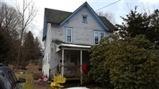 |  |  |  |  |  | Status: |  |  |  | Active
 |  |  |  |  |  | Roll Section: |  |  |  | Taxable
 |  |  |  |  |  | Swis: |  |  |  | 046401
 |  |  |  |  |  | Tax Map ID #: |  |  |  | 44.026-1-15
 |  |  |  |  |  | Property Class: |  |  |  | 210 - 1 Family Res
 |  |  |  |  |  | Site: |  |  |  | RES 1
 |  |  |  |  |  | In Ag. District: |  |  |  | No
 |  |  |  |  |  | Site Property Class: |  |  |  | 210 - 1 Family Res
 |  |  |  |  |  | Zoning Code: |  |  |  | -
 |  |  |  |  |  | Neighborhood Code: |  |  |  | 00000
Total Acreage/Size: |  |  | 66 x 202 |  |  | School District: |  |  |  | Cattaraugus - Little Valley
Land Assessment: |  |  | 2017 - $2,700 |  |  | Total Assessment: |  |  |  | 2017 - $29,000
Full Market Value: |  |  | 2017 - $43,939
Living Area: |  | 1,608 sq. ft. |  |  | First Story Area: |  |  |  |  | 984 sq. ft.
Second Story Area: |  | 624 sq. ft. |  |  | Half Story Area: |  |  |  |  | 0 sq. ft.
Finished Basement: |  | 0 sq. ft. |  |  | Number of Stories: |  |  |  |  | 2
Building Style: |  | Old style |  |  | Bathrooms (Full - Half): |  |  |  |  | 1 - 0
Bedrooms: |  | 3 |  |  | Kitchens: |  |  |  |  | 1
Fireplaces: |  | 0 |  |  | Basement Type: |  |  |  |  | Partial
Porch Type: |  | Porch-covered |  |  | Porch Area: |  |  |  |  | 160.00
Overall Condition: |  | Fair |  |  | Overall Grade: |  |  |  |  | Average
Year Built: |  | 1900
Structure | Size |  |  | Grade |  |  | Condition | Year
Porch-covered | 8 × 20 |  |  | Average |  |  | Normal | 1900
Porch-enclosed | 12 × 16 |  |  | Average |  |  | Normal | 1900
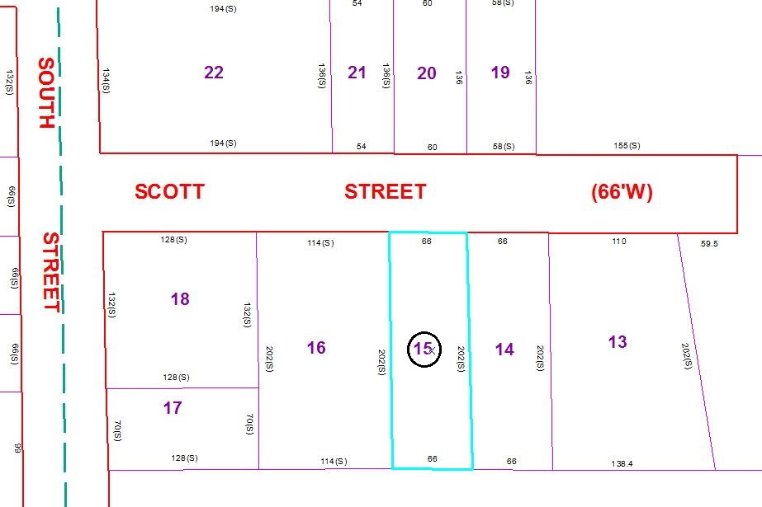
Approximate Yearly Taxes

School $597
Village $564
Town/County $758

Total $1,919

