Parcel 286
Kings Hwy N, Town of Napoli
NO PHOTO AVAILABLE |  | Status: | Active
 |  | Roll Section: | Taxable
 |  | Swis: | 046200
 |  | Tax Map ID #: | 62.046-3-18
 |  | Property Class: | 314 - Rural vac<10
 |  | Site: | RES 1
 |  | In Ag. District: | No
 |  | Site Property Class: | 314 - Rural vac<10
 |  | Zoning Code: | -
 |  | Neighborhood Code: | 62030
Total Acreage/Size: | 0.29 | School District: | Cattaraugus - Little Valley
Land Assessment: | 2017 - $700 | Total Assessment: | 2017 - $700
Full Market Value: | 2017 - $745
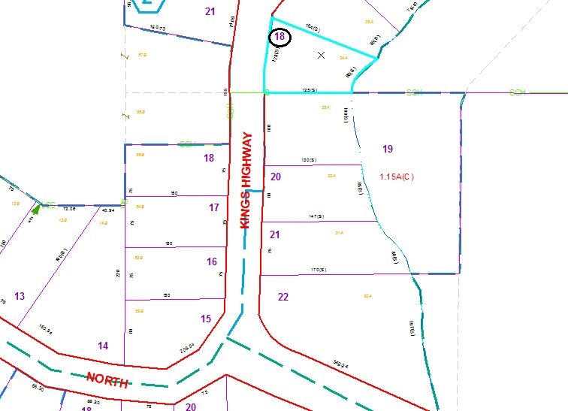
Approximate Yearly Taxes

School $11
Town/County $14

Total $25

