Parcel 285
4566 Allegany Rd, Town of Napoli
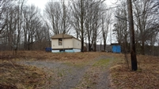 |  |  |  | Status: |  |  | Active
 |  |  |  | Roll Section: |  |  | Taxable
 |  |  |  | Swis: |  |  | 046200
 |  |  |  | Tax Map ID #: |  |  | 62.003-1-35.1
 |  |  |  | Property Class: |  |  | 270 – Mfg. housing
 |  |  |  | Site: |  |  | RES 1
 |  |  |  | In Ag. District: |  |  | No
 |  |  |  | Site Property Class: |  |  | 270 – Mfg. housing
 |  |  |  | Zoning Code: |  |  | -
 |  |  |  | Neighborhood Code: |  |  | 62020
Total Acreage/Size: |  | 111 x 209 |  | School District: |  |  | Randolph
Land Assessment: |  | 2017 - $3,600 |  | Total Assessment: |  |  | 2017 - $20,000
Full Market Value: |  | 2017 - $21,277
Structure | Size |  | Grade |  | Condition | Year
Mobile home | 66 × 14 |  | Minimum |  | Poor | 1988
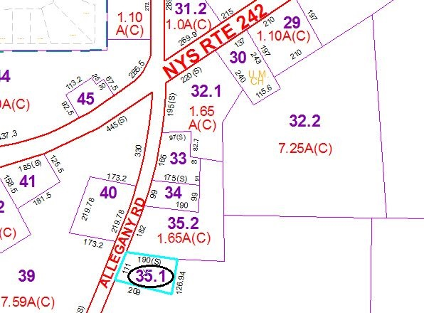
Approximate Yearly Taxes

School $203
Town/County $413

Total $616

