Parcel 277
6010 Toad Hollow Rd, Town of Mansfield
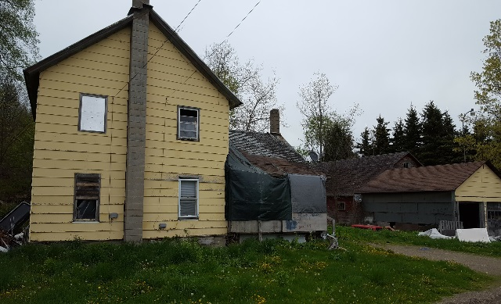 |  |  |  | Status: |  |  | Active
 |  |  |  | Roll Section: |  |  |  | Taxable
 |  |  |  | Swis: |  |  |  | 046000
 |  |  |  | Tax Map ID #: |  |  |  | 54.001-3-14
 |  |  |  | Property Class: |  |  |  | 210- Single Fam. Res
 |  |  |  | Site: |  |  |  | RES 1
 |  |  |  | In Ag. District: |  |  |  | No
 |  |  |  | Site Property Class: |  |  |  | 210- Single Fam. Res
 |  |  |  | Zoning Code: |  |  |  | -
 |  |  |  | Neighborhood Code: |  |  |  | 60050
Total Acreage/Size: |  | 1.19 |  | School District: |  |  |  | Cattaraugus - Little Valley
Land Assessment: |  | 2017 - $10,300 |  | Total Assessment: |  |  |  | 2017 - $10,300
Full Market Value: |  | 2017 - $10,300
Living Area: |  | 1,400 sq. ft. |  | First Story Area: |  |  |  |  | 850 sq. ft.
Second Story Area: |  | 550 sq. ft. |  | Half Story Area: |  |  |  |  | 0 sq. ft.
Finished Basement: |  | 0 sq. ft. |  | Number of Stories: |  |  |  |  | 2
Building Style: |  | Old style |  | Bathrooms (Full - Half): |  |  |  |  | 1 - 1
Bedrooms: |  | 4 |  | Kitchens: |  |  |  |  | 1
Fireplaces: |  | 0 |  | Basement Type: |  |  |  |  | Full
Porch Type: |  | Porch-covered |  | Porch Area: |  |  |  |  | 60.00
Overall Condition: |  | Fair |  | Overall Grade: |  |  |  |  | Average
Year Built: |  | 1915
Structure | Size |  | Grade |  | Condition | Year
Barn-1.5 gen | 18 × 34 |  | Economy |  | Fair | 1960
Gar-1.0 detached | 20 × 24 |  | Economy |  | Fair | 1940
Porch-covered | 60.00 sq. ft. |  | Average |  | Normal | 1915
Porch-enclosed | 10 × 20  HOUSE CONDEMNED |  | Average |  | Normal | 1900
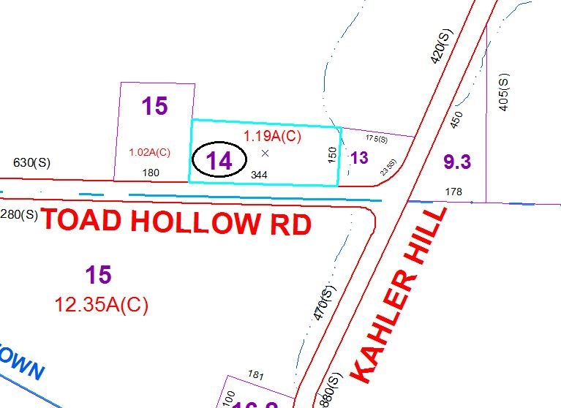
Approximate Yearly Taxes

School $151
Town/County $205

Total $356

