Parcel 275A
Byroads Rd, Town of Machias
No Photo Available |  |  |  |  | Status: | Active
 |  |  |  |  | Roll Section: | Taxable
 |  |  |  |  | Swis: | 045800
 |  |  |  |  | Tax Map ID #: | 30.002-1-3
 |  |  |  |  | Property Class: | 314 - Rural vac<10
 |  |  |  |  | Site: | RES 1
 |  |  |  |  | In Ag. District: | No
 |  |  |  |  | Site Property Class: | 314 - Rural vac<10
 |  |  |  |  | Zoning Code: | 01
 |  |  |  |  | Neighborhood Code: | 58050
Total Acreage/Size: | 2.62 |  |  |  | School District: | Yorkshire-Pioneer
Land Assessment: | 2017 - $11,400 |  |  |  | Total Assessment: | 2017 - $11,400
Full Market Value: | 2017 - $11,633  LANDLOCKED
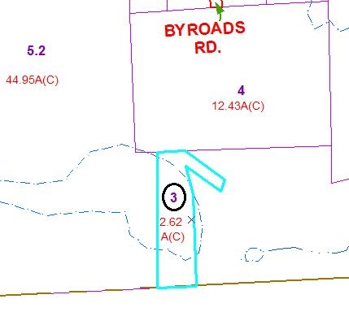
Approximate Yearly Taxes

School $154
Town/County $213

Total $367

