Parcel 273
46 Sunset Dr., Town of Machias
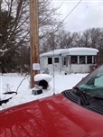 |  |  |  | Status: |  |  | Active
 |  |  |  | Roll Section: |  |  | Taxable
 |  |  |  | Swis: |  |  | 045800
 |  |  |  | Tax Map ID #: |  |  | 21.060-1-4
 |  |  |  | Property Class: |  |  | 271 – Mfg. housings
 |  |  |  | Site: |  |  | RES 1
 |  |  |  | In Ag. District: |  |  | No
 |  |  |  | Site Property Class: |  |  | 271 – Mfg. housings
 |  |  |  | Zoning Code: |  |  | 01
 |  |  |  | Neighborhood Code: |  |  | 58050
Total Acreage/Size: |  | 285 x 200 |  | School District: |  |  | Yorkshire-Pioneer
Land Assessment: |  | 2017 - $11,300 |  | Total Assessment: |  |  | 2017 - $48,100
Full Market Value: |  | 2017 - $49,082
Porch Type: |  | Porch-enclosed |  | Porch Area: |  |  | 160.00
Structure | Size |  | Grade |  | Condition | Year
Shed-machine | 8 × 8 |  | Economy |  | Fair | 1970
Shed-machine | 8 × 10 |  | Economy |  | Fair | 2000
Shed-machine | 4 × 6 |  | Economy |  | Fair | 2000
Mh:tip-out | 4 × 6 |  | Economy |  | Fair | 1970
Mobile home | 60 x 12 |  | Economy |  | Fair | 1970
Porch-enclosed | 20 x 8 |  | Economy |  | Fair | 1970
Porch-enclosed | 0 x 0 |  | Economy |  | Fair | 1980
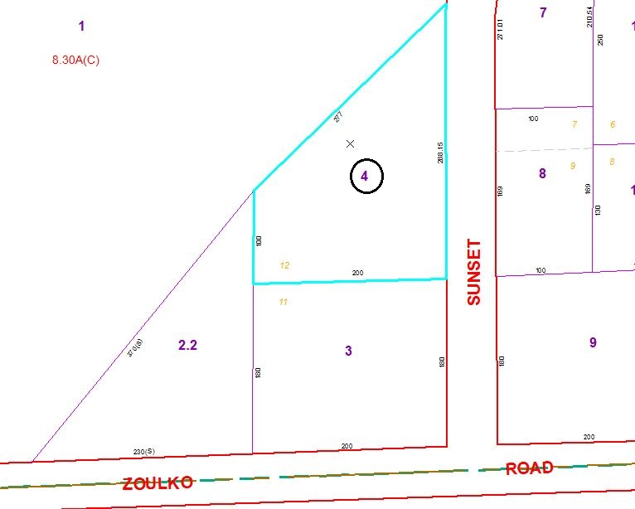
Approximate Yearly Taxes

School $649
Town/County $903

Total $1,552

