Parcel 259
212 Fair Oak St, Village of Little Valley
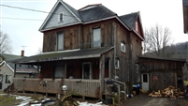 |  |  |  |  | Status: |  |  |  | Active
 |  |  |  |  | Roll Section: |  |  |  | Taxable
 |  |  |  |  | Swis: |  |  |  | 045401
 |  |  |  |  | Tax Map ID #: |  |  |  | 54.071-4-28
 |  |  |  |  | Property Class: |  |  |  | 210 - 1 Family Res
 |  |  |  |  | Site: |  |  |  | RES 1
 |  |  |  |  | In Ag. District: |  |  |  | No
 |  |  |  |  | Site Property Class: |  |  |  | 210 - 1 Family Res
 |  |  |  |  | Zoning Code: |  |  |  | -
 |  |  |  |  | Neighborhood Code: |  |  |  | 54150
Total Acreage/Size: |  |  | 66 x 165 |  | School District: |  |  |  | Cattaraugus - Little Valley
Land Assessment: |  |  | 2017 - $4,600 |  | Total Assessment: |  |  |  | 2017 - $32,000
Full Market Value: |  |  | 2017 - $47,761
Living Area: |  | 1,900 sq. ft. |  |  | First Story Area: |  |  |  |  | 1,157 sq. ft.
Second Story Area: |  | 743 sq. ft. |  |  | Half Story Area: |  |  |  |  | 0 sq. ft.
Finished Basement: |  | 0 sq. ft. |  |  | Number of Stories: |  |  |  |  | 2
Building Style: |  | Old style |  |  | Bathrooms (Full - Half): |  |  |  |  | 1 - 0
Bedrooms: |  | 4 |  |  | Kitchens: |  |  |  |  | 1
Fireplaces: |  | 0 |  |  | Basement Type: |  |  |  |  | Full
Porch Type: |  | Porch-covered |  |  | Porch Area: |  |  |  |  | 175.00
Basement Garage Cap: |  | 0 |  |  | Attached Garage Cap: |  |  |  |  | 374.00 sq. ft.
Overall Condition: |  | Fair |  |  | Overall Grade: |  |  |  |  | Average
Year Built: |  | 1925
Structure | Size |  |  | Grade |  | Condition |  | Year
Gar-1.0 attached | 17 × 22 |  |  | Average |  | Fair |  | 1940
Porch-covered | 175.00 sq. ft. |  |  | Average |  | Normal |  | 2000
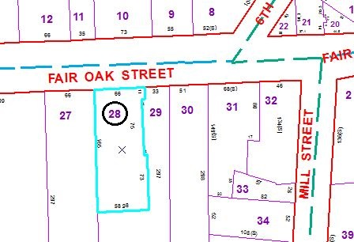
Approximate Yearly Taxes

School $659
Village $489
Town/County $804

Total $1,952

