Parcel 256
113 Erie St, Village of Little Valley
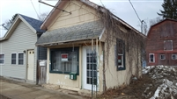 |  |  |  |  |  |  |  | Status: |  |  |  |  | Active
 |  |  |  |  |  |  |  | Roll Section: |  |  |  |  | Taxable
 |  |  |  |  |  |  |  | Swis: |  |  |  |  | 045401
 |  |  |  |  |  |  |  | Tax Map ID #: |  |  |  |  | 54.072-1-12
 |  |  |  |  |  |  |  | Property Class: |  |  |  |  | 423 - Snack bar
 |  |  |  |  |  |  |  | Site: |  |  |  |  | COM 1
 |  |  |  |  |  |  |  | In Ag. District: |  |  |  |  | No
 |  |  |  |  |  |  |  | Site Property Class: |  |  |  |  | 423 - Snack bar
 |  |  |  |  |  |  |  | Zoning Code: |  |  |  |  | -
 |  |  |  |  |  |  |  | Neighborhood Code: |  |  |  |  | 54150
Total Acreage/Size: |  |  |  | 14 x 20 |  |  |  | School District: |  |  |  |  | Cattaraugus - Little Valley
Land Assessment: |  |  |  | 2017 - $1,000 |  |  |  | Total Assessment: |  |  |  |  | 2017 - $5,700
Full Market Value: |  |  |  | 2017 - $8,507
Overall Eff Year Built: |  |  | 0 |  |  |  | Overall Condition: |  |  |  | Poor
Overall Grade: |  |  | Economy |  |  |  | Overall Desirability: |  |  |  | 1
AC% | Sprinkler% | Alarm% |  |  | Elevators | Basement Type |  |  | Year Built | Condition |  | Quality |  | Gross Floor Area (sq. ft.) |  |  | Stories
0 | 0 | 0 |  |  | 0 |  |  |  | 1900 | Poor |  | Economy |  | 240 |  |  | 1
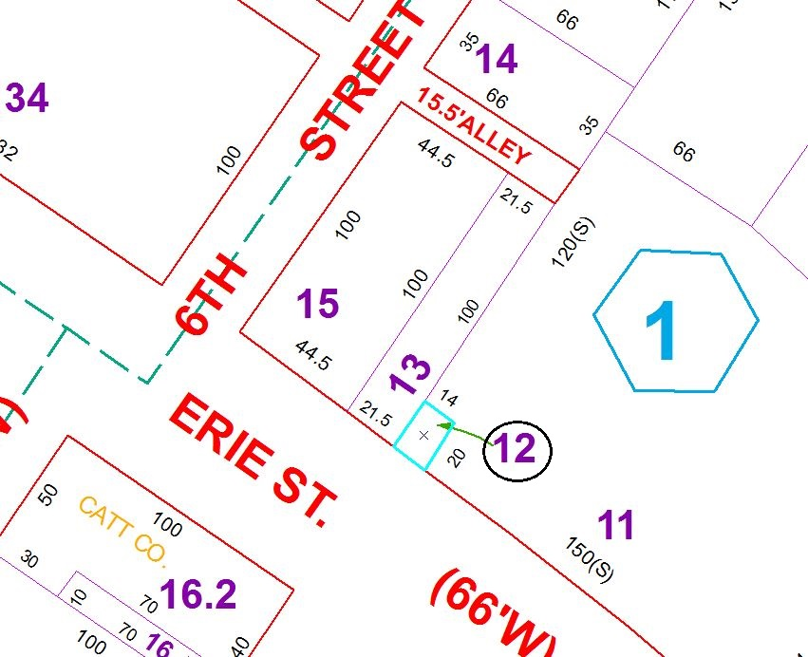
Approximate Yearly Taxes

School $117
Village $87
Town/County $144

Total $348

