Parcel 242
Union Hill Rd, Town of Ischua
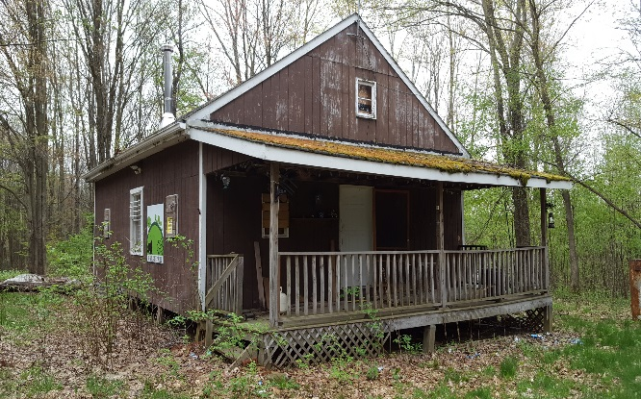 |  |  |  | Status: |  |  | Active
 |  |  |  | Roll Section: |  |  | Taxable
 |  |  |  | Swis: |  |  | 045000
 |  |  |  | Tax Map ID #: |  |  | 68.003-1-9.3
 |  |  |  | Property Class: |  |  | 260 - Seasonal res
 |  |  |  | Site: |  |  | RES 1
 |  |  |  | In Ag. District: |  |  | No
 |  |  |  | Site Property Class: |  |  | 260 - Seasonal res
 |  |  |  | Zoning Code: |  |  | 01
 |  |  |  | Neighborhood Code: |  |  | 50050 - Town
Total Acreage/Size: |  | 9.41 |  | School District: |  |  | Hinsdale
Land Assessment: |  | 2017 - $11,500 |  | Total Assessment: |  |  | 2017 - $55,300
Full Market Value: |  | 2017 - $62,841
Living Area: |  | 1,152 sq. ft. |  | First Story Area: |  |  | 768 sq. ft.
Second Story Area: |  | 0 sq. ft. |  | Half Story Area: |  |  | 384 sq. ft.
Finished Basement: |  | 0 sq. ft. |  | Number of Stories: |  |  | 1.5
Building Style: |  | Cottage |  | Bathrooms (Full - Half): |  |  | 1 - 0
Bedrooms: |  | 2 |  | Kitchens: |  |  | 1
Fireplaces: |  | 1 |  | Basement Type: |  |  | Slab/pier
Porch Type: |  | Porch-covered |  | Porch Area: |  |  | 192.00
Overall Condition: |  | Normal |  | Overall Grade: |  |  | Average
Year Built: |  | 1991
Structure | Size |  | Grade |  | Condition |  |  | Year
Porch-covered | 192.00 sq. ft. |  | Average |  | Normal |  |  | 1991
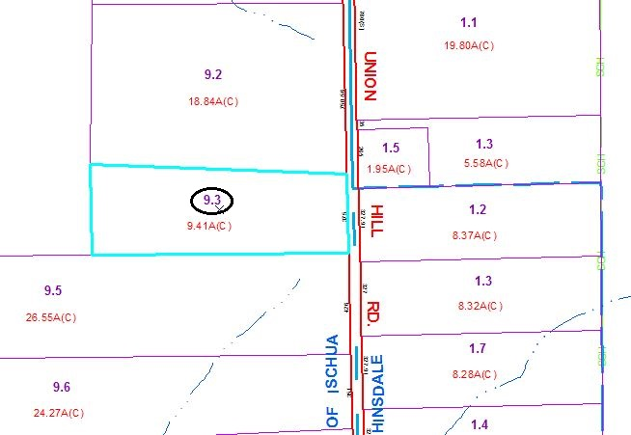
Approximate Yearly Taxes

School $561
Town/County $1,215

Total $1,776

