Parcel 211
11744 Rte. 98, Town of Freedom
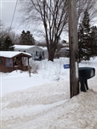 |  |  |  | Status: |  | Active
 |  |  |  | Roll Section: |  | Taxable
 |  |  |  | Swis: |  | 044200
 |  |  |  | Tax Map ID #: |  | 6.003-1-22
 |  |  |  | Property Class: |  | 210 - 1 Family Res
 |  |  |  | Site: |  | RES 1
 |  |  |  | In Ag. District: |  | No
 |  |  |  | Site Property Class: |  | 210 - 1 Family Res
 |  |  |  | Zoning Code: |  | 01
 |  |  |  | Neighborhood Code: |  | 04200 - Freedom
Total Acreage/Size: |  | 110 x 317 |  | School District: |  |  |  | Yorkshire-Pioneer
Land Assessment: |  | 2017 - $7,900 |  | Total Assessment: |  |  |  | 2017 - $106,200
Full Market Value: |  | 2017 - $106,200
Living Area: |  | 1,320 sq. ft. |  | First Story Area: |  |  |  | 1,320 sq. ft.
Finished Basement: |  | 0 sq. ft. |  | Number of Stories: |  |  |  | 1
Building Style: |  | Manuf'd Housing |  | Bathrooms (Full - Half): |  |  |  | 1 - 1
Bedrooms: |  | 3 |  | Kitchens: |  |  |  | 1
Fireplaces: |  | 1 |  | Basement Type: |  |  |  | Slab/pier
Porch Type: |  | Porch-open/deck |  | Porch Area: |  |  |  | 72.00
Overall Condition: |  | Normal |  | Overall Grade: |  |  |  | Average
Year Built: |  | 1995
Structure | Size |  | Grade |  | Condition |  | Year
Porch-open/deck | 8 × 9 |  | Economy |  | Fair |  | 1971
Gar-1.0 det. | 24 × 30 |  | Average |  | Normal |  | 1971
Shed-machine | 12 × 14 |  | Economy |  | Fair |  | 1971
Porch-enclosed | 8 × 10 |  | Average |  | Normal |  | 1971
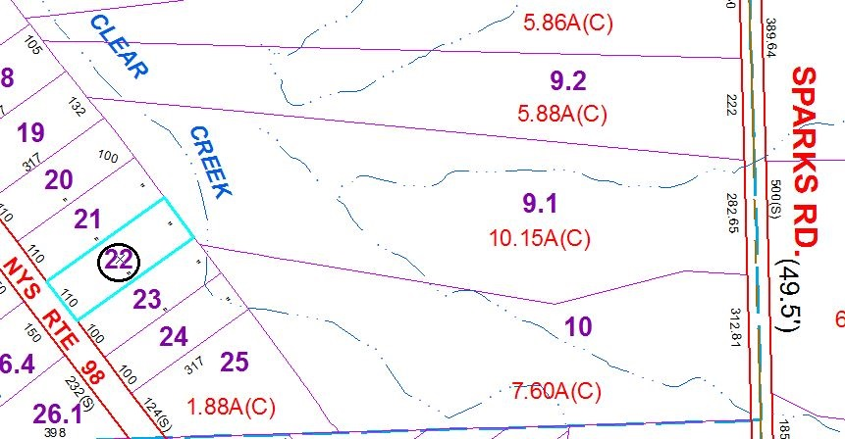
Approximate Yearly Taxes

School $1,432
Town/County $1,864

Total $3,296

