Parcel 210
11233 Scotch Rd, Town of Freedom
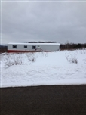 |  |  |  | Status: |  | Active
 |  |  |  | Roll Section: |  | Taxable
 |  |  |  | Swis: |  | 044200
 |  |  |  | Tax Map ID #: |  | 14.002-2-37.1
 |  |  |  | Property Class: |  | 270 – Mfg. housing
 |  |  |  | Site: |  | RES 1
 |  |  |  | In Ag. District: |  | No
 |  |  |  | Site Property Class: |  | 270 – Mfg. housing
 |  |  |  | Zoning Code: |  | 01
 |  |  |  | Neighborhood Code: |  | 04200 - Freedom
Total Acreage/Size: | 1.60 |  |  | School District: |  | Yorkshire-Pioneer
Land Assessment: | 2017 - $9,000 |  |  | Total Assessment: |  | 2017 - $37,300
Full Market Value: | 2017 - $37,300
Porch Type: | Porch-open/deck |  |  | Porch Area: |  | 16.00
Structure |  | Size | Grade |  | Condition |  | Year
Mobile home |  | 76 × 14 | Good |  | Normal |  | 2000
Porch-open/deck |  | 4 × 4 | Good |  | Normal |  | 2004
Porch-open/deck |  | 6 × 3 | Excellent |  | Normal |  | 2004

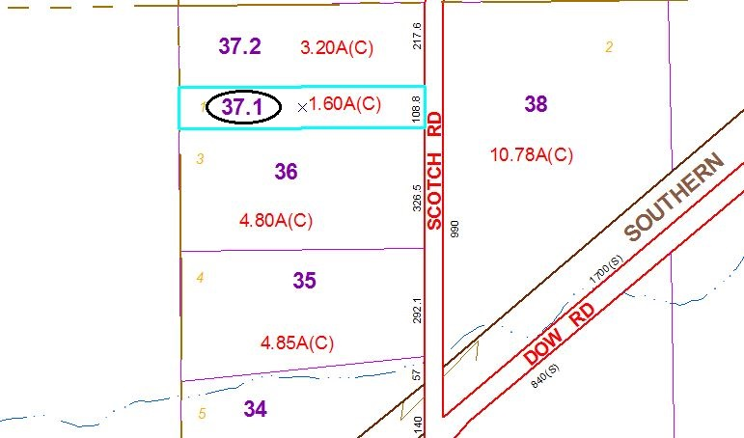
Approximate Yearly Taxes

School $503
Town/County $657

Total $1,160

