Parcel 208A
Mt Pleasant Ave, Village of Franklinville
No Photo Available |  | Status: | Active
 |  | Roll Section: | Taxable
 |  | Swis: | 044001
 |  | Tax Map ID #: | 40.078-2-6
 |  | Property Class: | 311 - Res vac land
 |  | Site: | RES 1
 |  | In Ag. District: | No
 |  | Site Property Class: | 311 - Res vac land
 |  | Zoning Code: | -
 |  | Neighborhood Code: | 40150
Total Acreage/Size: | 5 x 190.7 | School District: | Franklinville
Land Assessment: | 2017 - $200 | Total Assessment: | 2017 - $200
Full Market Value: | 2017 - $299
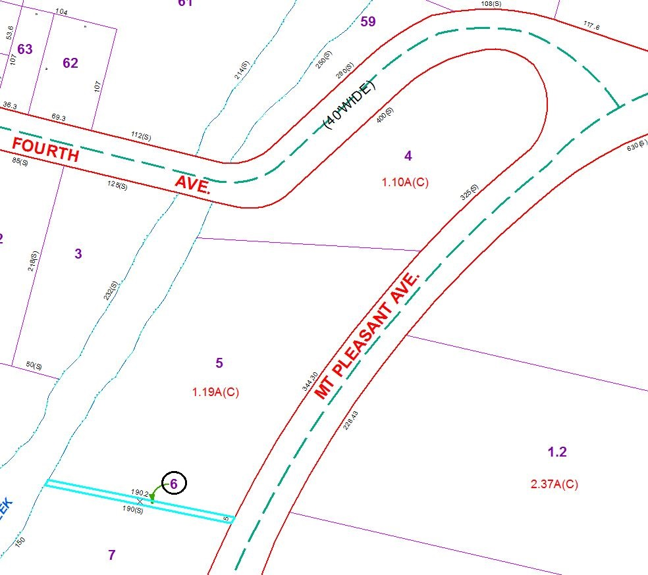
Approximate Yearly Taxes

School $5
Village $3
Town/County $6

Total $14

