Parcel 206
12 Riggs St, Village of Franklinville
See county website  For photo |  |  |  | Status: |  | Active
 |  |  |  | Roll Section: |  | Taxable
 |  |  |  | Swis: |  | 044001
 |  |  |  | Tax Map ID #: |  | 40.062-4-3.3
 |  |  |  | Property Class: |  | 210 - 1 Family Res
 |  |  |  | Site: |  | RES 1
 |  |  |  | In Ag. District: |  | No
 |  |  |  | Site Property Class: |  | 210 - 1 Family Res
 |  |  |  | Zoning Code: |  | -
 |  |  |  | Neighborhood Code: |  | 40150
Total Acreage/Size: |  | 60.4 x 120.2 |  | School District: |  | Franklinville
Land Assessment: |  | 2017 - $6,000 |  | Total Assessment: |  | 2017 - $35,000
Full Market Value: |  | 2017 - $52,239
Living Area: |  | 1,684 sq. ft. |  | First Story Area: |  |  |  | 1,156 sq. ft.
Second Story Area: |  | 528 sq. ft. |  | Half Story Area: |  |  |  | 0 sq. ft.
Finished Basement: |  | 0 sq. ft. |  | Number of Stories: |  |  |  | 2
Building Style: |  | Old style |  | Bathrooms (Full - Half): |  |  |  | 2 - 0
Bedrooms: |  | 3 |  | Kitchens: |  |  |  | 1
Fireplaces: |  | 0 |  | Basement Type: |  |  |  | Partial
Porch Type: |  | Porch-open/deck |  | Porch Area: |  |  |  | 200.00
Overall Condition: |  | Normal |  | Overall Grade: |  |  |  | Average
Year Built: |  | 1930
Structure | Size |  | Grade |  | Condition |  | Year
Porch-open/deck | 20 × 10 |  | Average |  | Normal |  | 1980
Porch-covered | 14 × 8 |  | Average |  | Normal |  | 1960
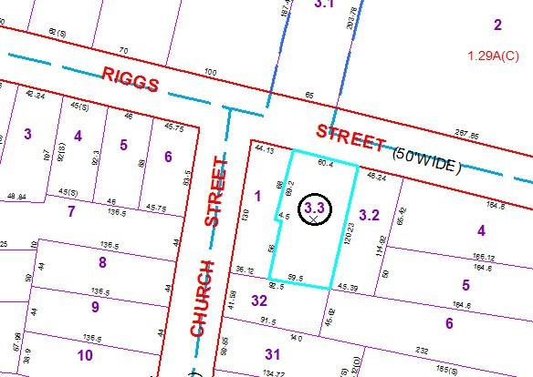
Approximate Yearly Taxes

School $921
Village $453
Town/County $1,028

Total $2,402

