Parcel 199
3529 Bakerstand Rd, Town of Franklinville
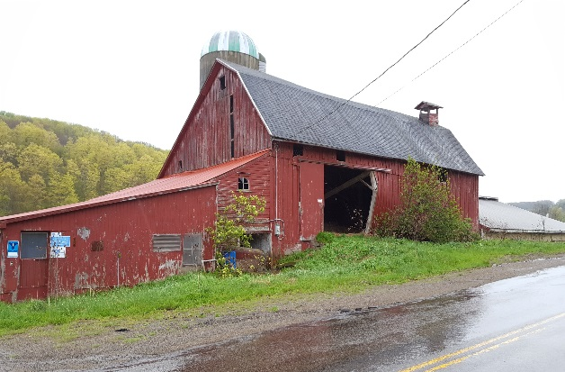 |  |  |  | Status: |  | Active
 |  |  |  | Roll Section: |  | Taxable
 |  |  |  | Swis: |  | 044089
 |  |  |  | Tax Map ID #: |  | 39.004-2-3.13
 |  |  |  | Property Class: |  | 312 - Vac w/improvement
 |  |  |  | Site: |  | RES 1
 |  |  |  | In Ag. District: |  | No
 |  |  |  | Site Property Class: |  | 312 - Vac w/improvement
 |  |  |  | Zoning Code: |  | -
 |  |  |  | Neighborhood Code: |  | 40350
Total Acreage/Size: |  | 20.50 |  | School District: |  | Franklinville
Land Assessment: |  | 2017 - $13,800 |  | Total Assessment: |  | 2017 - $43,800
Full Market Value: |  | 2017 - $65,373
Structure | Size |  | Grade |  | Condition |  | Year
Barn-1.0 dairy | 72 × 63 |  | Average |  | Normal |  | 1970
Barn-2.0 dairy | 70 × 60 |  | Average |  | Normal |  | 1920
Barn-1.0 dairy | 66 × 26 |  | Average |  | Normal |  | 1950
Shed-machine | 30 × 50  Approximate Yearly Taxes  School $1,153  Town/County $1,373  Total $2,526 |  | Average |  | Normal |  | 1975
