Parcel 185
5 Mill St, Village of Franklinville
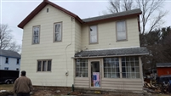 |  |  |  |  |  | Status: |  | Active
 |  |  |  |  |  | Roll Section: |  | Taxable
 |  |  |  |  |  | Swis: |  | 044001
 |  |  |  |  |  | Tax Map ID #: |  | 40.070-4-16
 |  |  |  |  |  | Property Class: |  | 210 - 1 Family Res
 |  |  |  |  |  | Site: |  | RES 1
 |  |  |  |  |  | In Ag. District: |  | No
 |  |  |  |  |  | Site Property Class: |  | 210 - 1 Family Res
 |  |  |  |  |  | Zoning Code: |  | -
 |  |  |  |  |  | Neighborhood Code: |  | 40150
Total Acreage/Size: |  |  | 72.6 x 267 |  |  | School District: |  | Franklinville
Land Assessment: |  |  | 2017 - $6,700 |  |  | Total Assessment: |  | 2017 - $37,000
Full Market Value: |  |  | 2017 - $55,224
Living Area: |  | 1,888 sq. ft. |  |  | First Story Area: |  |  |  | 944 sq. ft.
Second Story Area: |  | 944 sq. ft. |  |  | Half Story Area: |  |  |  | 0 sq. ft.
Finished Basement: |  | 0 sq. ft. |  |  | Number of Stories: |  |  |  | 2
Building Style: |  | Old style |  |  | Bathrooms (Full - Half): |  |  |  | 1 - 0
Bedrooms: |  | 4 |  |  | Kitchens: |  |  |  | 1
Fireplaces: |  | 0 |  |  | Basement Type: |  |  |  | Partial
Porch Type: |  | Porch-covered |  |  | Porch Area: |  |  |  | 96.00
Overall Condition: |  | Fair |  |  | Overall Grade: |  |  |  | Average
Year Built: |  | 1895
Structure | Size |  |  | Grade |  |  | Condition |  | Year
Shed-machine | 7 × 11 |  |  | Economy |  |  | Fair |  | 1990
Shed-machine | 8 × 14 |  |  | Economy |  |  | Fair |  | 1920
Porch-covered | 6 × 16 |  |  | Average |  |  | Normal |  | 1992
Shed-machine | 15 × 22 |  |  | Economy |  |  | Fair |  | 1920
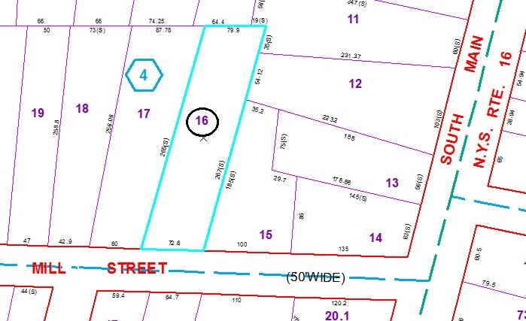
Approximate Yearly Taxes

School $974
Village $479
Town/County $1,086

Total $2,539

