Parcel 162
9033 E Otto-Springville Rd, Town of East Otto
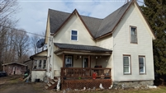 |  |  |  | Status: |  | Active
 |  |  |  | Roll Section: |  | Taxable
 |  |  |  | Swis: |  | 043200
 |  |  |  | Tax Map ID #: |  | 27.016-1-6
 |  |  |  | Property Class: |  | 210 - 1 Family Res
 |  |  |  | Site: |  | RES 1
 |  |  |  | In Ag. District: |  | No
 |  |  |  | Site Property Class: |  | 210 - 1 Family Res
 |  |  |  | Zoning Code: |  | -
 |  |  |  | Neighborhood Code: |  | 32050
Total Acreage/Size: |  | 82.5 x 239 |  | School District: |  | Cattaraugus - Little Valley
Land Assessment: |  | 2017 - $5,400 |  | Total Assessment: |  | 2017 - $55,000
Full Market Value: |  | 2017 - $55,000
Living Area: |  | 1,380 sq. ft. |  | First Story Area: |  |  | 1,016 sq. ft.
Second Story Area: |  | 0 sq. ft. |  | Half Story Area: |  |  | 364 sq. ft.
Finished Basement: |  | 0 sq. ft. |  | Number of Stories: |  |  | 1.7
Building Style: |  | Old style |  | Bathrooms (Full - Half): |  |  | 1 - 0
Bedrooms: |  | 4 |  | Kitchens: |  |  | 1
Fireplaces: |  | 0 |  | Basement Type: |  |  | Partial
Porch Type: |  | Porch-covered |  | Porch Area: |  |  | 160.00
Overall Condition: |  | Fair |  | Overall Grade: |  |  | Average
Year Built: |  | 1900
Structure | Size |  | Grade |  | Condition |  |  | Year
Shed-machine | 18 × 25 |  | Economy |  | Fair |  |  | 1965
Porch-covered | 10 × 16 |  | Average |  | Fair |  |  | 1900
Porch-enclosed | 6 × 10 |  | Average |  | Normal |  |  | 1900
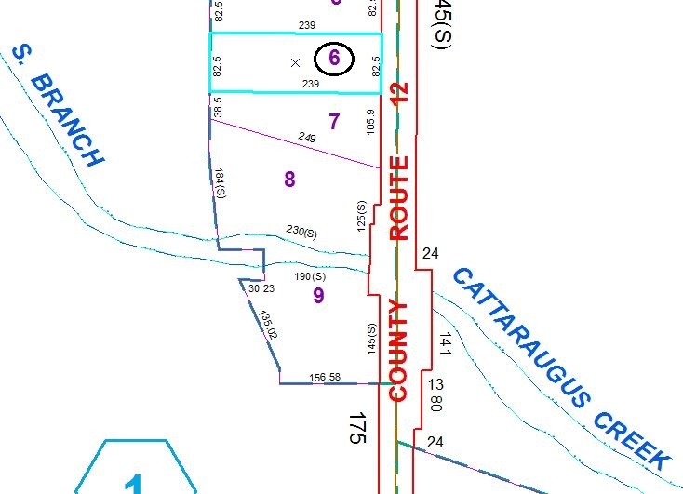
Approximate Yearly Taxes

School $803
Town/County $1,212

Total $2,015

