Parcel 160
17 Mill St, Village of South Dayton
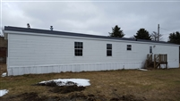 |  |  |  | Status: |  | Active
 |  |  |  | Roll Section: |  | Taxable
 |  |  |  | Swis: |  | 043001
 |  |  |  | Tax Map ID #: |  | 33.034-3-1.2
 |  |  |  | Property Class: |  | 270 – Mfg. housing
 |  |  |  | Site: |  | RES 1
 |  |  |  | In Ag. District: |  | No
 |  |  |  | Site Property Class: |  | 270 – Mfg. housing
 |  |  |  | Zoning Code: |  | -
 |  |  |  | Neighborhood Code: |  | 30080
Total Acreage/Size: |  | 69.5 x 200 |  | School District: |  | Pine Valley
Land Assessment: |  | 2017 - $1,800 |  | Total Assessment: |  | 2017 - $45,000
Full Market Value: |  | 2017 - $45,000
Structure | Size |  | Grade |  | Condition |  | Year
Mobile home | 70 × 14 |  | Average |  | Normal |  | 1989
Mobile home | 76 × 16 |  | Economy |  | Fair |  | 2007
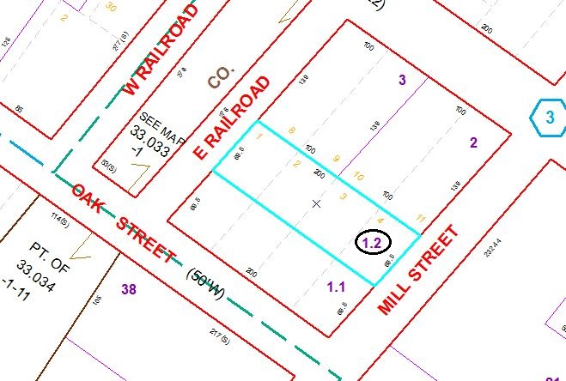
Approximate Yearly Taxes

School $994
Village $581
Town/County $850

Total $2,425

