Parcel 159
11457 First St, Town of Dayton
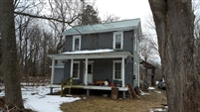 |  |  |  |  |  | Status: |  |  | Active
 |  |  |  |  |  | Roll Section: |  |  | Taxable
 |  |  |  |  |  | Swis: |  |  | 043089
 |  |  |  |  |  | Tax Map ID #: |  |  | 16.018-3-5.1
 |  |  |  |  |  | Property Class: |  |  | 210 - 1 Family Res
 |  |  |  |  |  | Site: |  |  | RES 1
 |  |  |  |  |  | In Ag. District: |  |  | No
 |  |  |  |  |  | Site Property Class: |  |  | 210 - 1 Family Res
 |  |  |  |  |  | Zoning Code: |  |  | -
 |  |  |  |  |  | Neighborhood Code: |  |  | 30050
Total Acreage/Size: |  |  | 0.63 |  |  | School District: |  |  | Gowanda
Land Assessment: |  |  | 2017 - $3,600 |  |  | Total Assessment: |  |  | 2017 - $58,100
Full Market Value: |  |  | 2017 - $58,100
Living Area: |  | 1,892 sq. ft. |  |  | First Story Area: |  |  |  |  |  | 1,048 sq. ft.
Second Story Area: |  | 844 sq. ft. |  |  | Half Story Area: |  |  |  |  |  | 0 sq. ft.
Finished Basement: |  | 0 sq. ft. |  |  | Number of Stories: |  |  |  |  |  | 2
Building Style: |  | Old style |  |  | Bathrooms (Full - Half): |  |  |  |  |  | 1 - 0
Bedrooms: |  | 4 |  |  | Kitchens: |  |  |  |  |  | 1
Fireplaces: |  | 0 |  |  | Basement Type: |  |  |  |  |  | Partial
Porch Type: |  | Porch-covered |  |  | Porch Area: |  |  |  |  |  | 192.00
Overall Condition: |  | Fair |  |  | Overall Grade: |  |  |  |  |  | Average
Year Built: |  | 1890
Structure | Size |  |  | Grade |  |  | Condition |  |  | Year
Porch-covered | 24 × 8 |  |  | Economy |  |  | Poor |  |  | 1900
Porch-covered | 24 × 6 |  |  | Economy |  |  | Fair |  |  | 1900
Porch-enclosed | 16 × 5 |  |  | Minimum |  |  | Poor |  |  | 1900
Barn-2.0 gen | 24 × 18 |  |  | Average |  |  | Fair |  |  | 1900
Shed-machine | 17 x 12 |  |  | Average |  |  | Poor |  |  | 1900
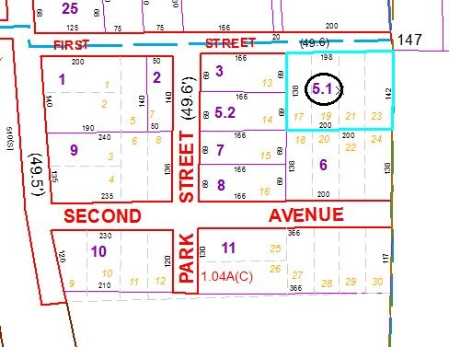
Approximate Yearly Taxes

School $1,056
Town/County $1,169

Total $2,225

