Parcel 156
15 Park St, Village of South Dayton
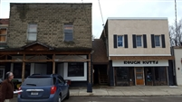 |  |  |  |  |  |  |  | Status: |  |  |  |  | Active
 |  |  |  |  |  |  |  | Roll Section: |  |  |  |  | Taxable
 |  |  |  |  |  |  |  | Swis: |  |  |  |  | 043001
 |  |  |  |  |  |  |  | Tax Map ID #: |  |  |  |  | 33.033-5-28
 |  |  |  |  |  |  |  | Property Class: |  |  |  |  | 421 - Restaurant
 |  |  |  |  |  |  |  | Site: |  |  |  |  | COM 1
 |  |  |  |  |  |  |  | In Ag. District: |  |  |  |  | No
 |  |  |  |  |  |  |  | Site Property Class: |  |  |  |  | 421 - Restaurant
 |  |  |  |  |  |  |  | Zoning Code: |  |  |  |  | -
 |  |  |  |  |  |  |  | Neighborhood Code: |  |  |  |  | 30080
Total Acreage/Size: |  |  |  | 58 x 91 |  |  |  | School District: |  |  |  |  | Pine Valley
Land Assessment: |  |  |  | 2017 - $3,000 |  |  |  | Total Assessment: |  |  |  |  | 2017 - $77,800
Full Market Value: |  |  |  | 2017 - $77,800
Overall Eff Year Built: |  |  | 0 |  |  |  | Overall Condition: |  |  |  | Fair
Overall Grade: |  |  | Economy |  |  |  | Overall Desirability: |  |  |  | 2
AC% | Sprinkler% | Alarm% |  |  | Elevators | Basement Type |  |  | Year Built | Condition |  | Quality |  | Gross Floor Area (sqft) |  |  | Stories
0 | 0 | 0 |  |  | 0 |  |  |  | 1930 | Fair |  | Average |  | 2520 |  |  | 2
0 | 0 | 0 |  |  | 0 |  |  |  | 1900 | Fair |  | Average |  | 4680
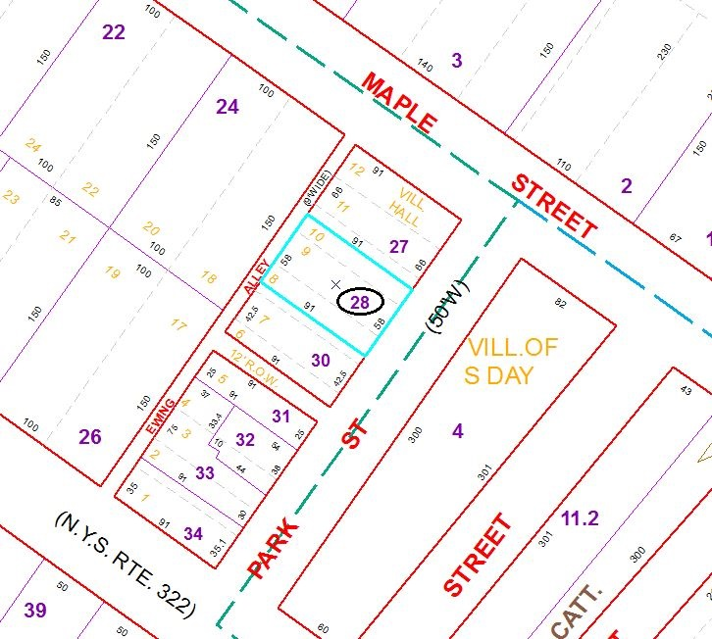
Approximate Yearly Taxes

School $1,719
Village $1,004
Town/County $1,468

Total $4,191

