Parcel 150
227 Mill St, Village of South Dayton
 |  |  |  | Status: |  | Active
 |  |  |  | Roll Section: |  | Taxable
 |  |  |  | Swis: |  | 043001
 |  |  |  | Tax Map ID #: |  | 33.034-1-16
 |  |  |  | Property Class: |  | 210 - 1 Family Res
 |  |  |  | Site: |  | RES 1
 |  |  |  | In Ag. District: |  | No
 |  |  |  | Site Property Class: |  | 210 - 1 Family Res
 |  |  |  | Zoning Code: |  | -
 |  |  |  | Neighborhood Code: |  | 30080
Total Acreage/Size: |  | 116.1 x 220 |  | School District: |  | Pine Valley
Land Assessment: |  | 2017 - $5,600 |  | Total Assessment: |  | 2017 - $27,000
Full Market Value: |  | 2017 - $27,000
Living Area: |  | 1,075 sq. ft. |  | First Story Area: |  |  | 1,075 sq. ft.
Building Style: |  | Old style |  | Bathrooms (Full - Half): |  |  | 1 - 0
Bedrooms: |  | 3 |  | Kitchens: |  |  | 1
Fireplaces: |  | 0 |  | Basement Type: |  |  | Crawl
Porch Type: |  | Porch-covered |  | Porch Area: |  |  | 175.00
Basement Garage Cap: |  | 0 |  | Attached Garage Cap: |  |  | 888.00 sq. ft.
Overall Condition: |  | Fair |  | Overall Grade: |  |  | Economy
Year Built: |  | 1906
Structure | Size |  | Grade |  | Condition |  | Year
Gar-1.0 attached | 37 × 24 |  | Average |  | Fair |  | 1920
Shed-machine | 37 × 10 |  | Minimum |  | Fair |  | 1920
Porch-covered | 25 × 7 |  | Minimum |  | Fair |  | 1982
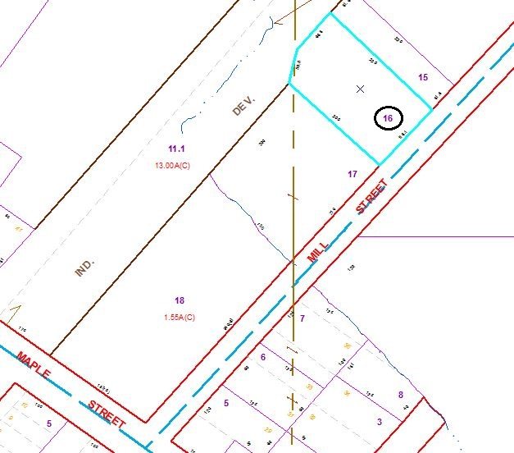
Approximate Yearly Taxes

School $596
Village $349
Town/County $510

Total $1,455

