Parcel 148
9621 Rte. 62, Town of Dayton
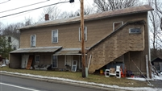 |  |  |  |  |  |  |  | Status: |  |  |  | Active
 |  |  |  |  |  |  |  | Roll Section: |  |  |  | Taxable
 |  |  |  |  |  |  |  | Swis: |  |  |  | 043089
 |  |  |  |  |  |  |  | Tax Map ID #: |  |  |  | 16.018-2-8
 |  |  |  |  |  |  |  | Property Class: |  |  |  | 400 - Commercial
 |  |  |  |  |  |  |  | Site: |  |  |  | COM 1
 |  |  |  |  |  |  |  | In Ag. District: |  |  |  | No
 |  |  |  |  |  |  |  | Site Property Class: |  |  |  | 400 - Commercial
 |  |  |  |  |  |  |  | Zoning Code: |  |  |  | -
 |  |  |  |  |  |  |  | Neighborhood Code: |  |  |  | 30050
Total Acreage/Size: |  |  |  | 0.75 |  |  |  | School District: |  |  |  | Gowanda
Land Assessment: |  |  |  | 2017 - $5,400 |  |  |  | Total Assessment: |  |  |  | 2017 - $30,000
Full Market Value: |  |  |  | 2017 - $30,000
Overall Eff Year Built: |  |  | 0 |  |  |  | Overall Condition: |  |  |  | Fair
Overall Grade: |  |  | Average |  |  |  | Overall Desirability: |  |  |  | 2
AC% | Sprinkler% | Alarm% |  |  | Elevators | Basement Type |  |  | Year Built | Condition |  |  | Quality | Gross Floor Area (sq. ft.) |  |  | Stories
0 | 0 | 0 |  |  | 0 |  |  |  | 1900 | Normal |  |  | Average | 3720 |  |  | 2
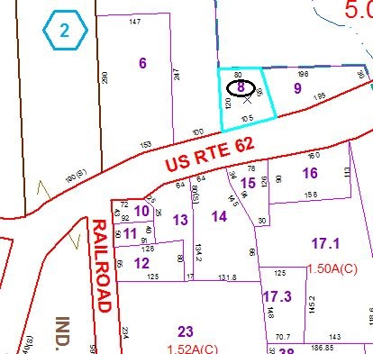
Approximate Yearly Taxes

School $545
Town/County $580

Total $1,125

