Parcel 145
5315 NYS Rte. 241, Town of Conewango
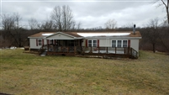 |  |  |  | Status: |  |  | Active
 |  |  |  | Roll Section: |  |  | Taxable
 |  |  |  | Swis: |  |  | 042800
 |  |  |  | Tax Map ID #: |  |  | 60.002-2-25.1
 |  |  |  | Property Class: |  |  | 270 – Mfg. housing
 |  |  |  | Site: |  |  | RES 1
 |  |  |  | In Ag. District: |  |  | No
 |  |  |  | Site Property Class: |  |  | 270 – Mfg. housing
 |  |  |  | Zoning Code: |  |  | JMH
 |  |  |  | Neighborhood Code: |  |  | 28050
Total Acreage/Size: |  | 3.25 |  | School District: |  |  | Randolph
Land Assessment: |  | 2017 - $5,500 |  | Total Assessment: |  |  | 2017 - $47,800
Full Market Value: |  | 2017 - $95,600
Structure | Size |  | Grade |  | Condition | Year
Shed-machine | 60 × 12 |  | Minimum |  | Poor | 1979
Gar-1.0 detached | 20 × 14 |  | Average |  | Fair | 1990
Mobile home | 66 × 28 |  | Average |  | Normal | 1993
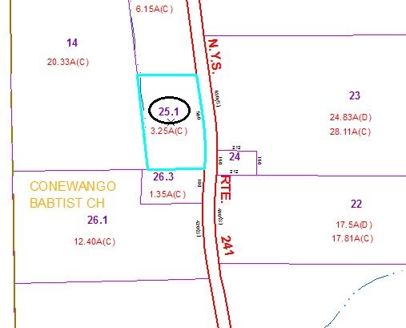
Approximate Yearly Taxes

School $931
Town/County $1,812

Total $2,743

