Parcel 131
5437 Nichols Run Rd, Town of Carrollton
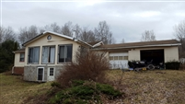 |  |  |  |  |  | Status: |  |  |  | Active
 |  |  |  |  |  | Roll Section: |  |  |  | Taxable
 |  |  |  |  |  | Swis: |  |  |  | 042400
 |  |  |  |  |  | Tax Map ID #: |  |  |  | 110.002-1-13.3
 |  |  |  |  |  | Property Class: |  |  |  | 210 - 1 Family Res
 |  |  |  |  |  | Site: |  |  |  | RES 1
 |  |  |  |  |  | In Ag. District: |  |  |  | No
 |  |  |  |  |  | Site Property Class: |  |  |  | 210 - 1 Family Res
 |  |  |  |  |  | Zoning Code: |  |  |  | 01
 |  |  |  |  |  | Neighborhood Code: |  |  |  | 24050
Total Acreage/Size: |  |  | 9.90 |  |  | School District: |  |  |  | Allegany - Limestone
Land Assessment: |  |  | 2017 - $17,900 |  |  | Total Assessment: |  |  |  | 2017 - $74,500
Full Market Value: |  |  | 2017 - $86,628
Living Area: |  | 1,008 sq. ft. |  |  | First Story Area: |  |  |  |  |  | 1,008 sq. ft.
Finished Basement: |  | 0 sq. ft. |  |  | Number of Stories: |  |  |  |  |  | 1
Finished Rec Room |  | 724 sq. ft. |  |  | Finished Area Over Garage |  |  |  |  |  | 0 sq. ft.
Building Style: |  | Ranch |  |  | Bathrooms (Full - Half): |  |  |  |  |  | 1 - 0
Bedrooms: |  | 3 |  |  | Kitchens: |  |  |  |  |  | 1
Fireplaces: |  | 0 |  |  | Basement Type: |  |  |  |  |  | Full
Porch Type: |  | Porch-covered |  |  | Porch Area: |  |  |  |  |  | 240.00
Basement Garage Cap: |  | 0 |  |  | Attached Garage Cap: |  |  |  |  |  | 720.00 sq. ft.
Overall Condition: |  | Normal |  |  | Overall Grade: |  |  |  |  |  | Good
Year Built: |  | 1983
Structure | Size |  |  | Grade |  |  | Condition |  | Year
Gar-1.0 attached | 30 × 24 |  |  | Average |  |  | Normal |  | 1983
Porch-covered | 12 × 20 |  |  | Economy |  |  | Fair |  | 1994
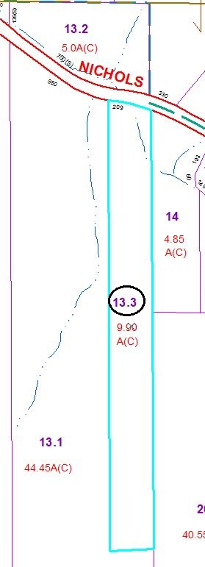
MINIMUM BID $25,000
Approximate Yearly Taxes

School $1,509
Town/County $1,470

Total $2,979

