Parcel 122
1905 Chipmonk Rd, Town of Carrollton
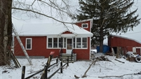 |  |  |  |  |  | Status: |  |  |  | Active
 |  |  |  |  |  | Roll Section: |  |  |  | Taxable
 |  |  |  |  |  | Swis: |  |  |  | 042400
 |  |  |  |  |  | Tax Map ID #: |  |  |  | 92.004-1-4.2
 |  |  |  |  |  | Property Class: |  |  |  | 210 - 1 Family Res
 |  |  |  |  |  | Site: |  |  |  | RES 1
 |  |  |  |  |  | In Ag. District: |  |  |  | No
 |  |  |  |  |  | Site Property Class: |  |  |  | 210 - 1 Family Res
 |  |  |  |  |  | Zoning Code: |  |  |  | 01
 |  |  |  |  |  | Neighborhood Code: |  |  |  | 24050
Total Acreage/Size: |  |  | 130 x 175 |  |  | School District: |  |  |  | Allegany - Limestone
Land Assessment: |  |  | 2017 - $6,100 |  |  | Total Assessment: |  |  |  | 2017 - $39,000
Full Market Value: |  |  | 2017 - $45,349
Living Area: |  | 1,196 sq. ft. |  |  | First Story Area: |  |  |  |  | 956 sq. ft.
Second Story Area: |  | 240 sq. ft. |  |  | Half Story Area: |  |  |  |  | 0 sq. ft.
Finished Basement: |  | 0 sq. ft. |  |  | Number of Stories: |  |  |  |  | 2
Building Style: |  | Old style |  |  | Bathrooms (Full - Half): |  |  |  |  | 1 - 1
Bedrooms: |  | 3 |  |  | Kitchens: |  |  |  |  | 1
Fireplaces: |  | 0 |  |  | Basement Type: |  |  |  |  | Partial
Porch Type: |  | Porch-enclosed |  |  | Porch Area: |  |  |  |  | 120.00
Overall Condition: |  | Normal |  |  | Overall Grade: |  |  |  |  | Economy
Year Built: |  | 1940
Structure | Size |  |  | Grade |  |  | Condition |  | Year
Porch-enclosed | 20 × 6 |  |  | Average |  |  | Normal |  | 1940
Porch-enclosed | 10 × 6 |  |  | Average |  |  | Normal |  | 1940
Gar-1.0 detached | 54 × 20 |  |  | Average |  |  | Fair |  | 1940
Porch-covered | 24.00 sq. ft. |  |  | Average |  |  | Normal |  | 1940
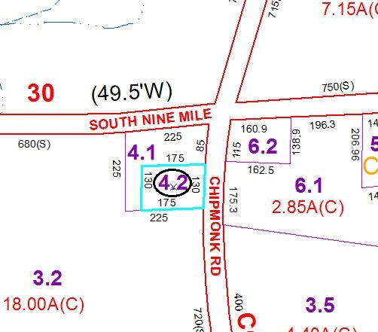
Approximate Yearly Taxes

School $790
Town/County $770

Total $1,560

