Parcel 100
Celeste Dr. Off, Town of Allegany
No Photo Available |  | Status: | Active
 |  | Roll Section: | Taxable
 |  | Swis: | 042089
 |  | Tax Map ID #: | 93.036-1-2.5
 |  | Property Class: | 314 - Rural vac<10
 |  | Site: | RES 1
 |  | In Ag. District: | No
 |  | Site Property Class: | 314 - Rural vac<10
 |  | Zoning Code: | -
 |  | Neighborhood Code: | 20314
Total Acreage/Size: | 4.45 | School District: | Allegany - Limestone
Land Assessment: | 2017 - $37,600 | Total Assessment: | 2017 - $37,600
Full Market Value: | 2017 - $38,763
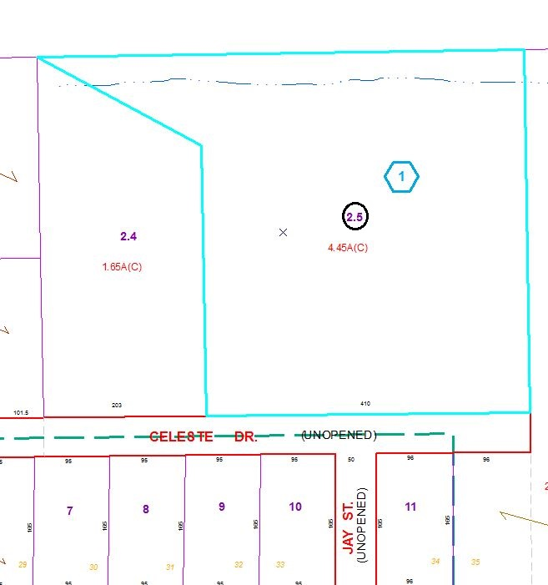
Approximate Yearly Taxes

School $663
Town/County $722

Total $1,385

