Parcel 9

616 Henley St W, City of Olean
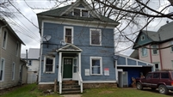 |  |  |  |  |  |  |  | Status: |  |  |  | Active
 |  |  |  |  |  |  |  | Roll Section: |  |  |  | Taxable
 |  |  |  |  |  |  |  | Swis: |  |  |  | 041200
 |  |  |  |  |  |  |  | Tax Map ID #: |  |  |  | 94.064-13-31
 |  |  |  |  |  |  |  | Account #: |  |  |  | 024440
 |  |  |  |  |  |  |  | Property Class: |  |  |  | 220 - 2 Family Res
 |  |  |  |  |  |  |  | Site: |  |  |  | RES 1
 |  |  |  |  |  |  |  | In Ag. District: |  |  |  | No
 |  |  |  |  |  |  |  | Site Property Class: |  |  |  | 220 - 2 Family Res
 |  |  |  |  |  |  |  | Zoning Code: |  |  |  | -
 |  |  |  |  |  |  |  | Neighborhood Code: |  |  |  | 12204
Total Acreage/Size: |  |  |  | 45 x 107 |  |  |  | School District: |  |  |  | Olean
Land Assessment: |  |  |  | 2016 - $3,600 |  |  |  | Total Assessment: |  |  |  | 2016 - $43,900
Full Market Value: |  |  |  | 2016 - $47.717
Living Area: |  |  | 2,322 sq. ft. |  |  | First Story Area: |  |  |  |  | 1,308 sq. ft.
Second Story Area: |  |  | 720 sq. ft. |  |  | Half Story Area: |  |  |  |  | 294 sq. ft.
Finished Basement: |  |  | 0 sq. ft. |  |  | Number of Stories: |  |  |  |  | 2
Building Style: |  |  | Old style |  |  | Bathrooms (Full - Half): |  |  |  |  | 2 - 1
Bedrooms: |  |  | 3 |  |  | Kitchens: |  |  |  |  | 2
Fireplaces: |  |  | 0 |  |  | Basement Type: |  |  |  |  | Full
Porch Type: |  |  | Porch-covered |  |  | Porch Area: |  |  |  |  | 18.00
Overall Condition: |  |  | Fair |  |  | Overall Grade: |  |  |  |  | Average
Year Built: |  |  | 1900
Structure | Size |  |  |  | Grade |  | Condition |  |  | Year
Porch-covered |  | 3 × 6 |  |  | Economy |  | Poor |  |  | 1900
Porch-enclosed |  | 7 × 14 |  |  | Average |  | Normal |  |  | 1900
Carport |  | 12 × 14 |  |  | Economy |  | Fair |  |  | 1970
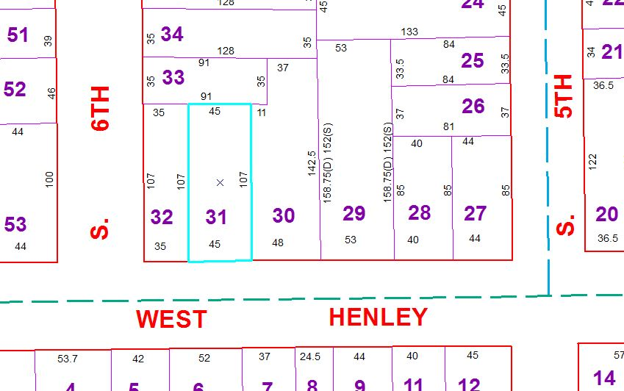
Approximate Yearly Taxes

School $1,125
City $599
County $633

Total $2,357

