Parcel 87

179 Hillside Dr, Town of Carrollton
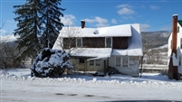 |  |  |  |  |  |  | Status: |  |  |  | Active
 |  |  |  |  |  |  | Roll Section: |  |  |  | Taxable
 |  |  |  |  |  |  | Swis: |  |  |  | 042400
 |  |  |  |  |  |  | Tax Map ID #: |  |  |  | 110.001-2-6
 |  |  |  |  |  |  | Account #: |  |  |  | 0322
 |  |  |  |  |  |  | Property Class: |  |  |  | 210 - 1 Family Res
 |  |  |  |  |  |  | Site: |  |  |  | RES 1
 |  |  |  |  |  |  | In Ag. District: |  |  |  | No
 |  |  |  |  |  |  | Site Property Class: |  |  |  | 210 - 1 Family Res
 |  |  |  |  |  |  | Zoning Code: |  |  |  | 01
 |  |  |  |  |  |  | Neighborhood Code: |  |  |  | 24050
Total Acreage/Size: |  |  | 85 x 90 |  |  |  | School District: |  |  |  | Allegany - Limestone
Land Assessment: |  |  | 2016 - $3,500 |  |  |  | Total Assessment: |  |  |  | 2016 - $10,000
Full Market Value: |  |  | 2016 - $11,494
Living Area: |  | 1,729 sq. ft. |  |  | First Story Area: |  |  |  |  | 988 sq. ft.
Additional Story Area: |  | 0 sq. ft. |  |  | 3/4 Story Area: |  |  |  |  | 741 sq. ft.
Finished Basement: |  | 0 sq. ft. |  |  | Number of Stories: |  |  |  |  | 1.7
Building Style: |  | Old style |  |  | Bathrooms (Full - Half): |  |  |  |  | 1 - 0
Bedrooms: |  | 6 |  |  | Kitchens: |  |  |  |  | 1
Fireplaces: |  | 0 |  |  | Basement Type: |  |  |  |  | Partial
Porch Type: |  | Porch-enclosed |  |  | Porch Area: |  |  |  |  | 70.00
Basement Garage Cap: |  | 1 |  |  | Attached Garage Cap: |  |  |  |  | 0.00 sq. ft.
Overall Condition: |  | Poor |  |  | Overall Grade: |  |  |  |  | Average
Year Built: |  | 1940
Structure | Size |  |  | Grade |  | Condition |  | Year
Porch-enclosed | 10 × 7 |  |  | Average |  | Normal |  | 1940
Porch-enclosed | 7 × 6 |  |  | Average |  | Normal |  | 1940
Porch-covered | 128 sq. ft. |  |  | Average |  | Normal |  | 1940
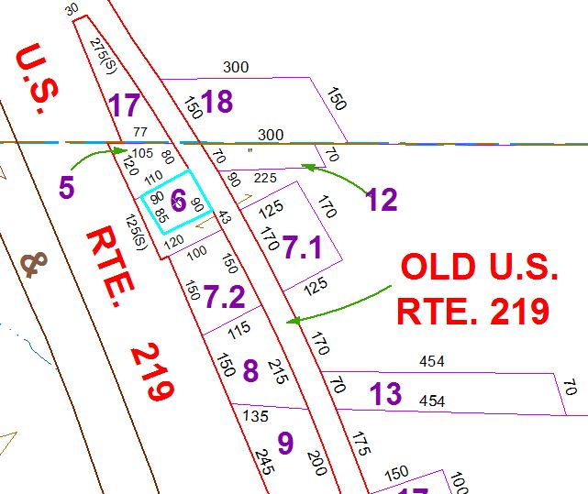
Approximate Yearly Taxes

School $212
Town/County $202

Total $414

