Parcel 8

217 Barry St S, City of Olean
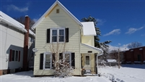 |  |  |  |  |  | Status: |  |  |  |  | Active
 |  |  |  |  |  | Roll Section: |  |  |  |  | Taxable
 |  |  |  |  |  | Swis: |  |  |  |  | 041200
 |  |  |  |  |  | Tax Map ID #: |  |  |  |  | 94.073-4-25
 |  |  |  |  |  | Account #: |  |  |  |  | 002170
 |  |  |  |  |  | Property Class: |  |  |  |  | 210 - 1 Family Res
 |  |  |  |  |  | Site: |  |  |  |  | RES 1
 |  |  |  |  |  | In Ag. District: |  |  |  |  | No
 |  |  |  |  |  | Site Property Class: |  |  |  |  | 210 - 1 Family Res
 |  |  |  |  |  | Zoning Code: |  |  |  |  | -
 |  |  |  |  |  | Neighborhood Code: |  |  |  |  | 12203
Total Acreage/Size: |  |  | 37.5 x 115 |  |  | School District: |  |  |  |  | Olean
Land Assessment: |  |  | 2016- $3,200 |  |  | Total Assessment: |  |  |  |  | 2016 - $58,000
Full Market Value: |  |  | 2016- $63,043
Living Area: |  | 1,498 sq. ft. |  |  | First Story Area: |  |  |  |  | 892 sq. ft.
Second Story Area: |  | 606 sq. ft. |  |  | Half Story Area: |  |  |  |  | 0 sq. ft.
Building Style: |  | Old style |  |  | Bathrooms (Full - Half): |  |  |  |  | 1 - 0
Bedrooms: |  | 3 |  |  | Kitchens: |  |  |  |  | 1
Fireplaces: |  | 0 |  |  | Basement Type: |  |  |  |  | Partial
Porch Type: |  | Porch-covered |  |  | Porch Area: |  |  |  |  | 84.00
Basement Garage Cap: |  | 0 |  |  | Attached Garage Cap: |  |  |  |  | 440.00 sq. ft.
Overall Condition: |  | Normal |  |  | Overall Grade: |  |  |  |  | Average
Year Built: |  | 1920
Structure | Size |  |  | Grade |  |  | Condition |  | Year
Shed-machine | 8 × 8 |  |  | Average |  |  | Normal |  | 1975
Gar-1.0 att. | 22 × 20 |  |  | Average |  |  | Normal |  | 1920
Porch-covered | 6 × 14 |  |  | Average |  |  | Normal |  | 1920
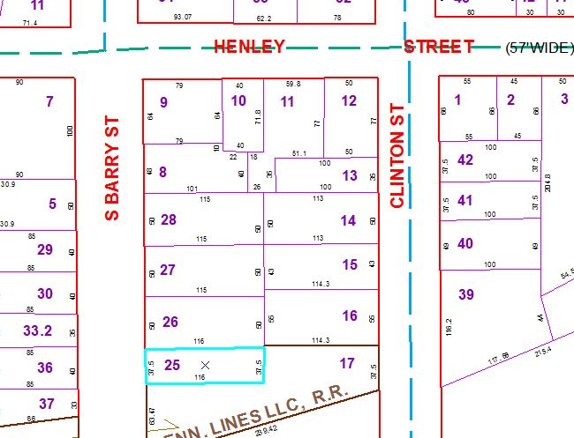
Approximate Yearly Taxes

School $1,486
City $837
County $791

Total $3,114

