Parcel 78

9308 NYS Rte. 240, Town of Ashford
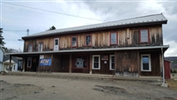 |  |  |  |  |  |  |  |  |  |  |  | Status: |  |  |  |  | Active
 |  |  |  |  |  |  |  |  |  |  |  | Roll Section: |  |  |  |  | Taxable
 |  |  |  |  |  |  |  |  |  |  |  | Swis: |  |  |  |  | 042200
 |  |  |  |  |  |  |  |  |  |  |  | Tax Map ID #: |  |  |  |  | 29.011-2-37
 |  |  |  |  |  |  |  |  |  |  |  | Account #: |  |  |  |  | 0754
 |  |  |  |  |  |  |  |  |  |  |  | Property Class: |  |  |  |  | 482 – Det. row bldg.
 |  |  |  |  |  |  |  |  |  |  |  | Site: |  |  |  |  | COM 1
 |  |  |  |  |  |  |  |  |  |  |  | In Ag. District: |  |  |  |  | No
 |  |  |  |  |  |  |  |  |  |  |  | Site Property Class: |  |  |  |  | 482 – Det. row bldg.
 |  |  |  |  |  |  |  |  |  |  |  | Zoning Code: |  |  |  |  | -
 |  |  |  |  |  |  |  |  |  |  |  | Neighborhood Code: |  |  |  |  | 22010
Total Acreage/Size: |  |  |  |  |  | 2.25 |  |  |  |  |  | School District: |  |  |  |  | West Valley
Land Assessment: |  |  |  |  |  | 2016 - $6,000 |  |  |  |  |  | Total Assessment: |  |  |  |  | 2016 - $54,100
Full Market Value: |  |  |  |  |  | 2016 - $94,912
Overall Eff Year Built: |  |  |  | 1900 |  |  |  |  | Overall Condition: |  |  |  |  | Normal
Overall Grade: |  |  |  | Economy |  |  |  |  | Overall Desirability: |  |  |  |  | 3
AC% | Sprinkler% |  | Alarm% |  | Elevators |  |  | Basement Type |  | Year Built |  |  | Condition |  |  | Quality |  | Gross Floor Area (sqft) |  |  | Stories
0 | 0 |  | 0 |  | 0 |  |  | 0 |  | 1900 |  |  | Normal |  |  | Average |  | 7296 |  |  | 2.00
Structure |  | Size |  |  |  |  | Grade |  |  |  | Condition |  |  |  | Year
Barn-pole |  | 40 × 30 |  |  |  |  | Economy |  |  |  | Normal |  |  |  | 1980
Porch-covered |  | 68 × 7 |  |  |  |  | Average |  |  |  | Normal |  |  |  | 1930
Porch-covered |  | 30 × 6 |  |  |  |  | Average |  |  |  | Normal |  |  |  | 1930
Porch-up open |  | 12 × 10 |  |  |  |  | Average |  |  |  | Normal |  |  |  | 1930
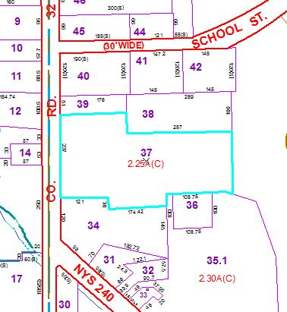
Approximate Yearly Taxes

School $2,133
Town/County $1,646

Total $3,779

