Parcel 66A & 66B

330 & 332 Tenth St N, City of Olean
Parcels are being sold together
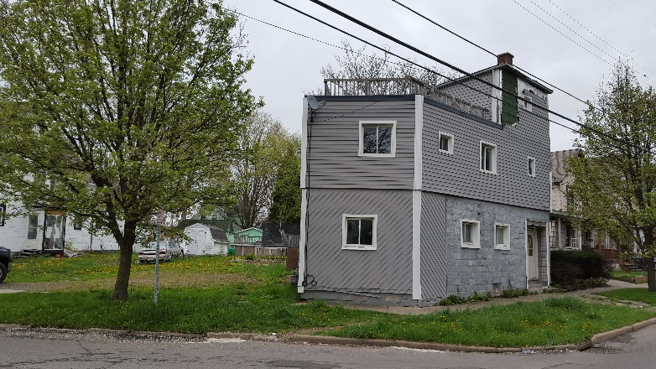 |  |  |  |  |  |  | Status: |  |  | Active
 |  |  |  |  |  |  | Roll Section: |  |  | Taxable
 |  |  |  |  |  |  | Swis: |  |  | 041200
 |  |  |  |  |  |  | Tax Map ID #: |  |  | 94.056-4-35.2  94.056-4-34
 |  |  |  |  |  |  | Account #: |  |  | 055585
 |  |  |  |  |  |  | Property Class: |  |  | 220 - 2 Family Res
 |  |  |  |  |  |  | Site: |  |  | RES 1
 |  |  |  |  |  |  | In Ag. District: |  |  | No
 |  |  |  |  |  |  | Site Property Class: |  |  | 220 - 2 Family Res
 |  |  |  |  |  |  | Zoning Code: |  |  | -
 |  |  |  |  |  |  | Neighborhood Code: |  |  | 12204
Total Acreage/Size: |  |  | 53.5x45.6 |  |  |  | School District: |  |  | Olean
Land Assessment: |  |  | 2016 - $1,400 |  |  |  | Total Assessment: |  |  | 2016 - $38,800
Full Market Value: |  |  | 2016 - $42,170
Living Area: |  | 2,552 sq. ft. |  |  | First Story Area: |  |  |  | 1,161 sq. ft.
Second Story Area: |  | 1,161 sq. ft. |  |  | Number of Stories: |  |  |  | 3
Additional Story Area: |  | 230 sq. ft.
Building Style: |  | Old style |  |  | Bathrooms Full - Half: |  |  |  | 2 - 0
Bedrooms: |  | 3 |  |  | Kitchens: |  |  |  | 2
Overall Condition: |  | Normal |  |  | Basement Type: |  |  |  | Full
Year Built: |  | 1938 |  |  | Overall Grade: |  |  |  | Economy
Structure | Size |  |  | Grade |  | Condition |  | Year  Approximate Yearly Taxes  School $995  City $560  County $530  Total $2,085
User defined |  |  |  | Average |  | Fair |  | 1970

